Hibernate:

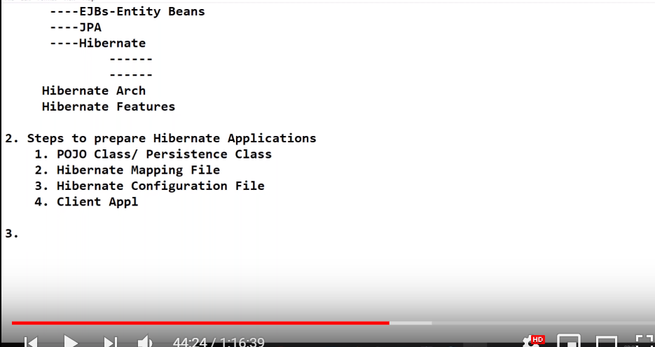

* It is an ORM[Object-Relational Mapping] implementation/tool.
* It is applicable for 95% of Enterprise application.
* Enterprise application is divided in 3 layers.. a) Presentation , b) Business and c)Persistance layer.
* Hibernate will be used in persistence layer.
  + Persistence technologies
    - Serialization and Deserialization. In CORE
    - JDBC
    - ORM
      * EJBs entity base.
      * JPA.
      * Hibernate.

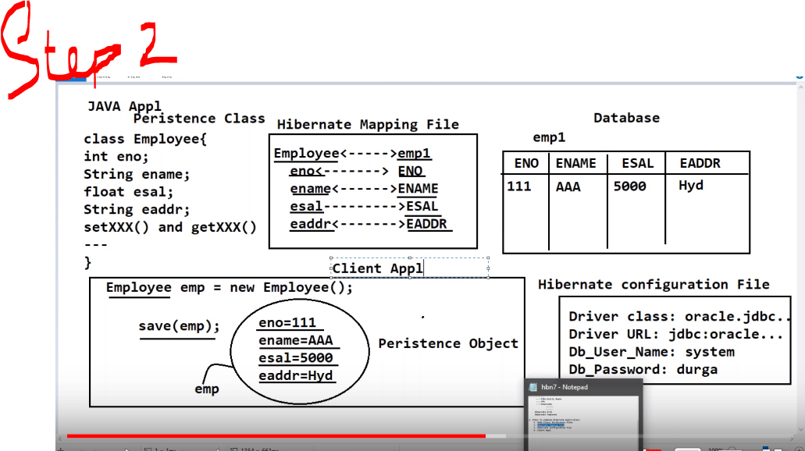

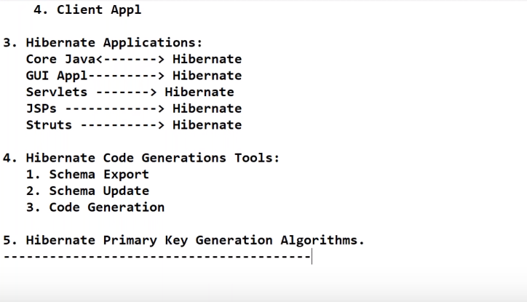

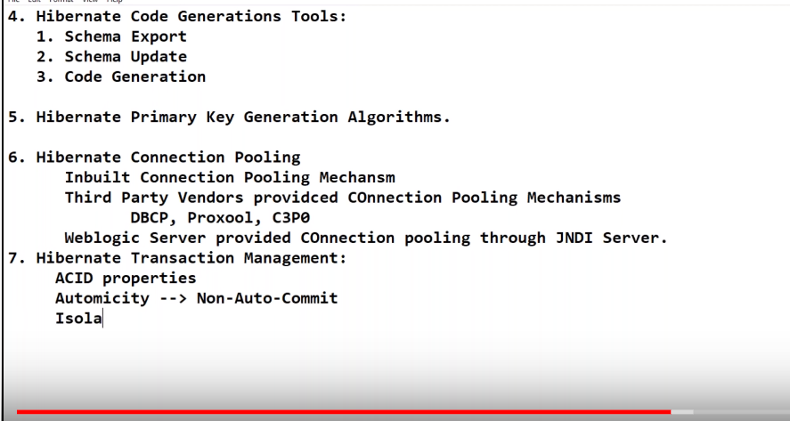

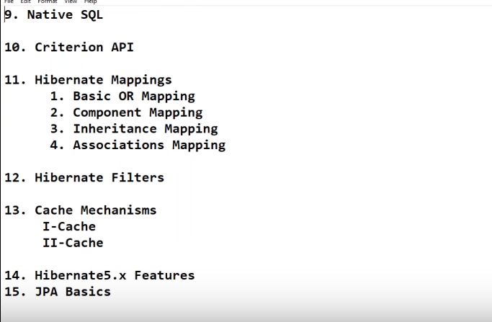

Hibernate by JavaBrains:--

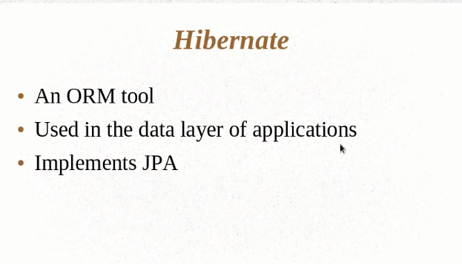

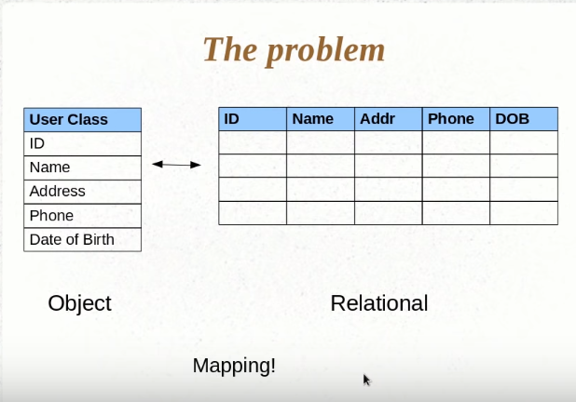

* A class corresponds to a table and an object of a class corresponds to a row.

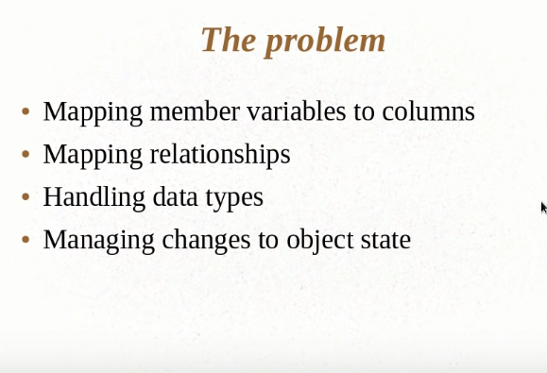

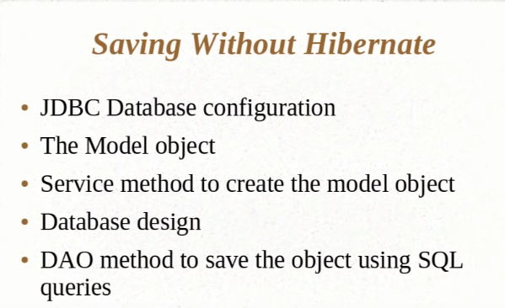

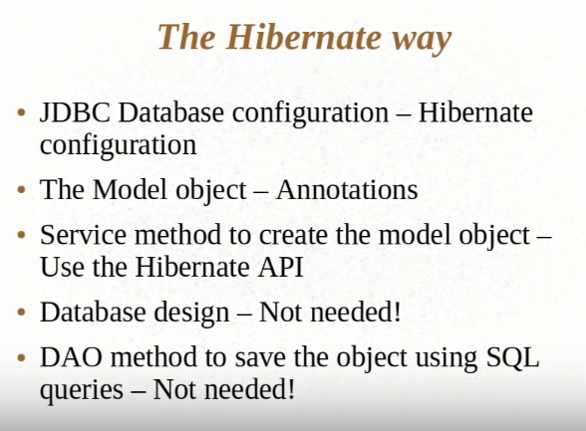

Using the hibernate API to persist the data:--

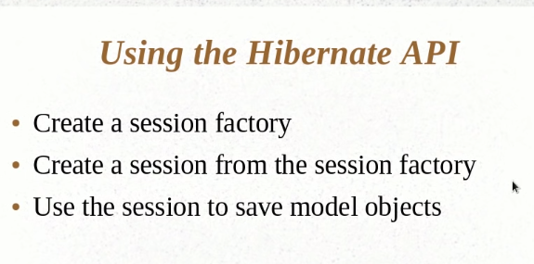

New Configuration().configure() //Used to read the cfg file to understand the config of database.

* If the below will be create then hibernate will drop and re-create the table for every run.. but if we change it to update then it will do the change in schema if and only if it finds any change.

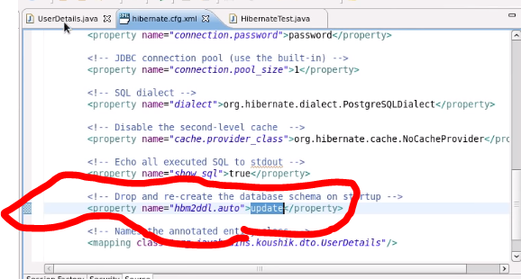

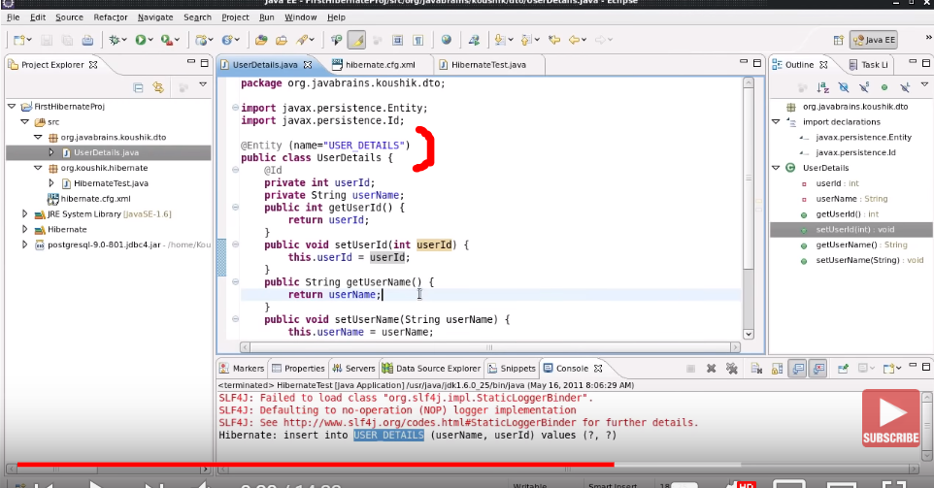

* Or else you can you @Table(name=”ABC”), just to name the table and the name of the entity will remain default.

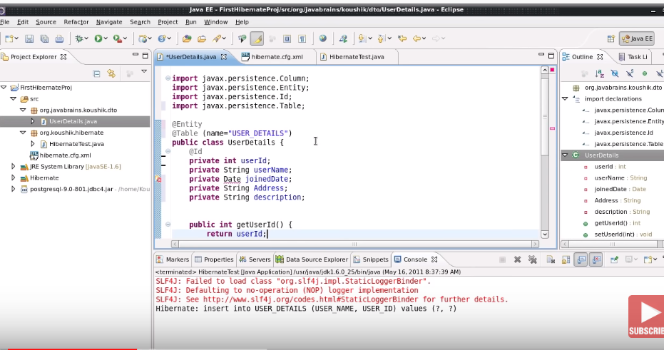

* @Basic() :- having 2 different params once we can use fetchType and insteadOf fetchType you can use optional tag.
* @Transient is used to skip the field to insert or can say it makes it optional.

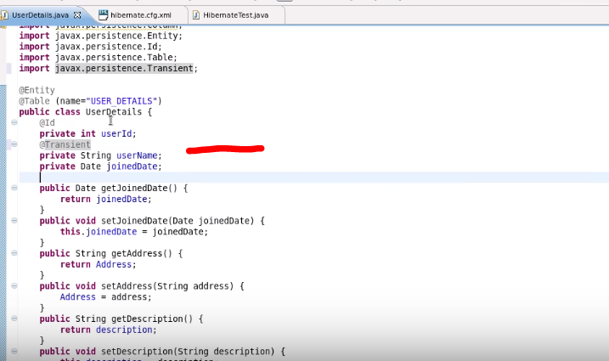

* @Temporal is used to give the DATE format.
* 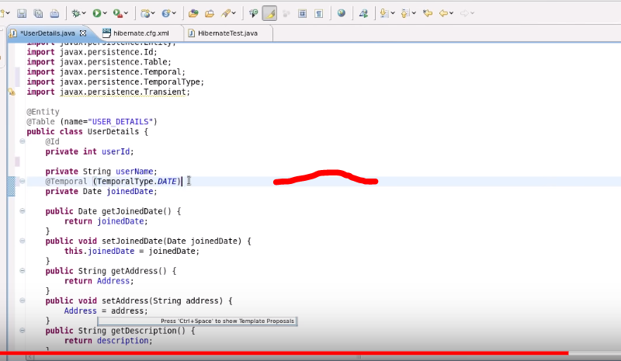
* @Lob is actually used to increase the default size and stands for LargeObject, here CLOB will be picked by default as we are trying over String datatype.
* CLOB , BLOB stands for Character LOB or BYTE stream LOB.
* 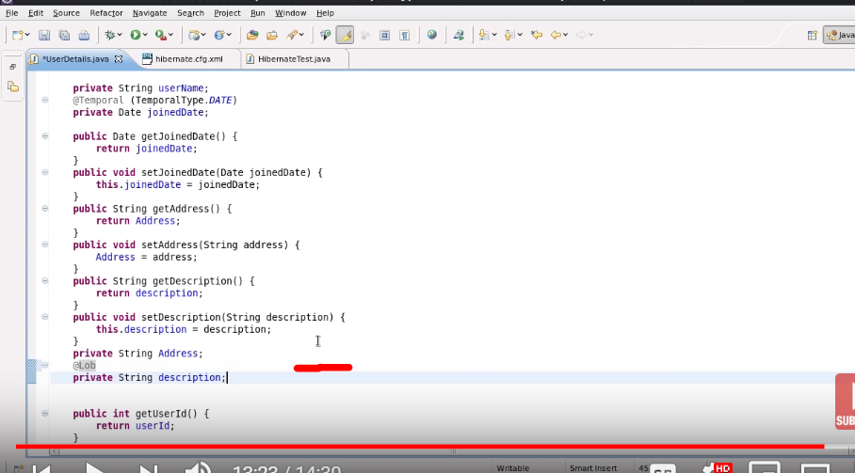

Hibernate Tutorial 06 - Retrieving Objects using session.get

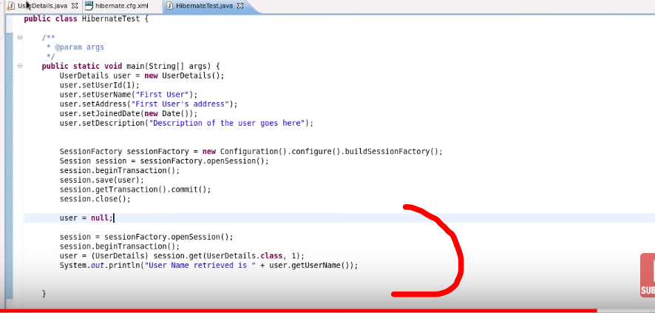

# Hibernate Tutorial 07 - Primary Keys

Keys are of 2 types: a) Natural , b)Surrogate Key.

1. Natural key: The attribute which is already a part of table.
2. Surrogate key: A new attr. We need to add for the sake of PK / it will auto inc. (Need to google it out)

* @GeneratedValue is used to autoincrement, and is bydefault uses AUTO as Generated type.

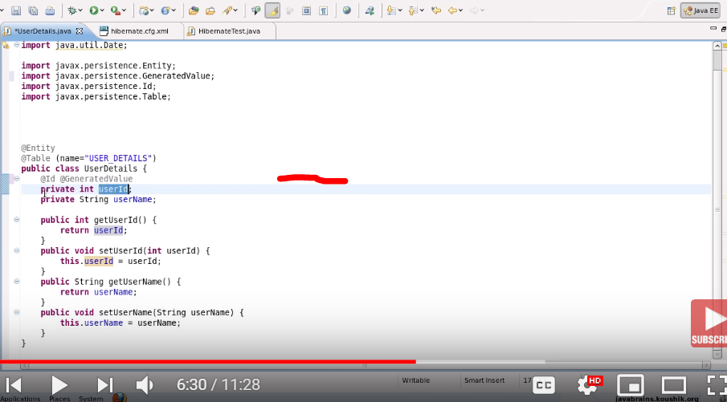

* Need to check

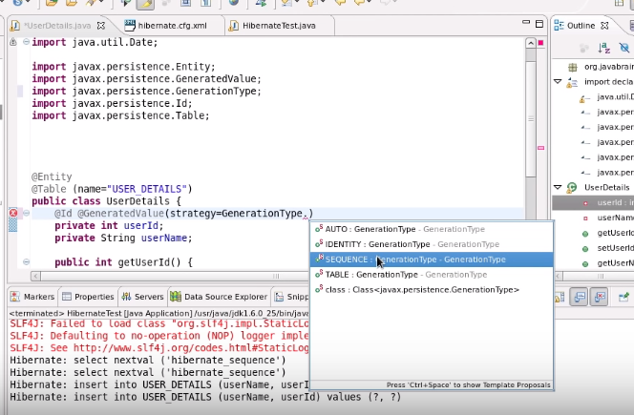

# Hibernate Tutorial 08 - Value Types and Embedding Objects

Q: What is entity data and what is value data?

A: entity data is something that provides meaning to itself (Class EMPLOYEE)and value data(Class ADDRESS) is something that provides meaning to different objects.

In below SS we will be replacing Address obj and will provide it’s attribute. (it’s attribute will be value data)

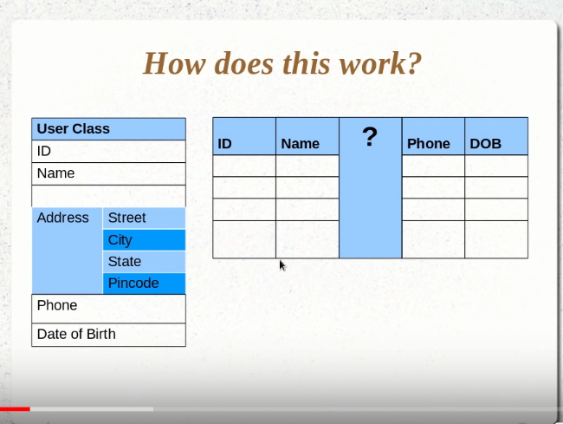 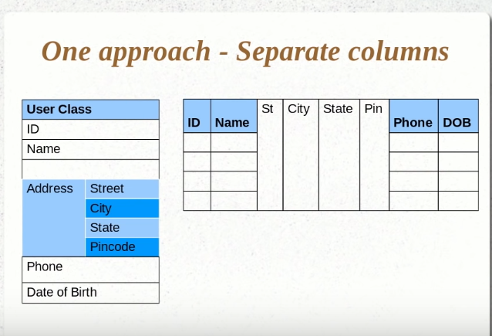

@Embeddable is used for Address class , and create a Complex object as ADDRESS (and annotate it as @Embedded at address instance var.)in userDetails class.

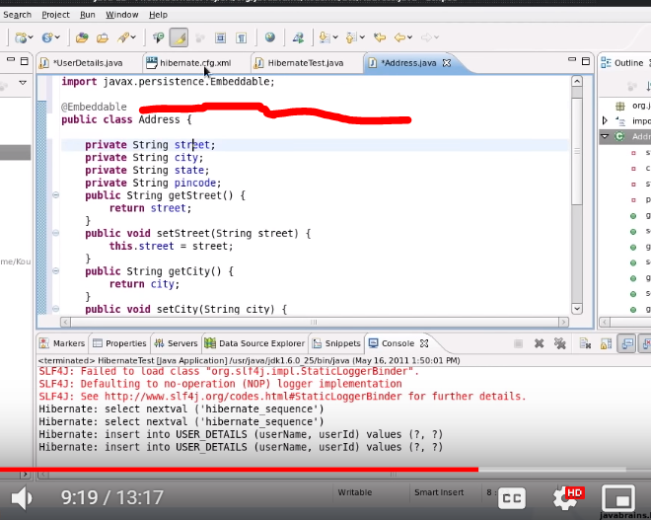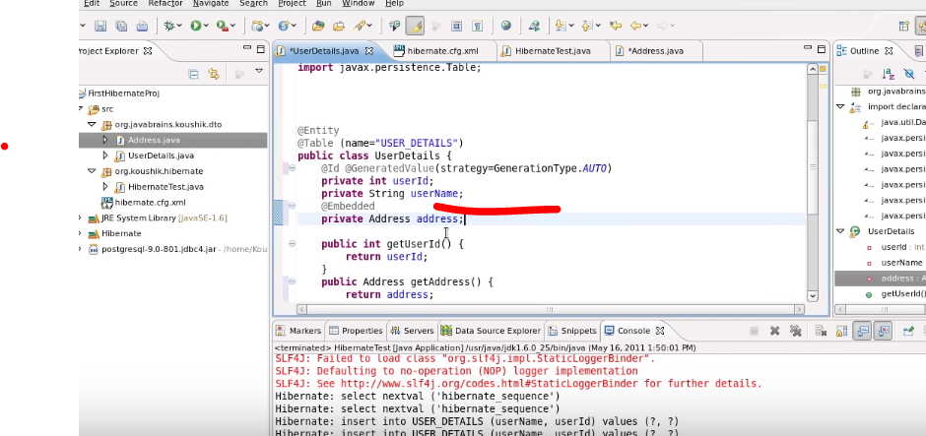 Then save().

@Entity is useful with model classes to denote that this is the entity or table, and is identified by HQL.

@Table is used to provide any specific name to your table if you want to provide any different name

Note: if you don't use @Table then hibernate consider that @Entity is your table name by default and @Entity must

Code to do : done HibernateTest00.java

* If we are using @Embeddable then it is not mandatory to use @Embedded annotation.
* Try to fetch these values i.e. that embeddable ADDRESS from DB.

Now , Let’s say we have to change the name of the column as created by Address Class, there will be 2 ways : trythis—Done both

1. Change the names in the Address.java class itself , like

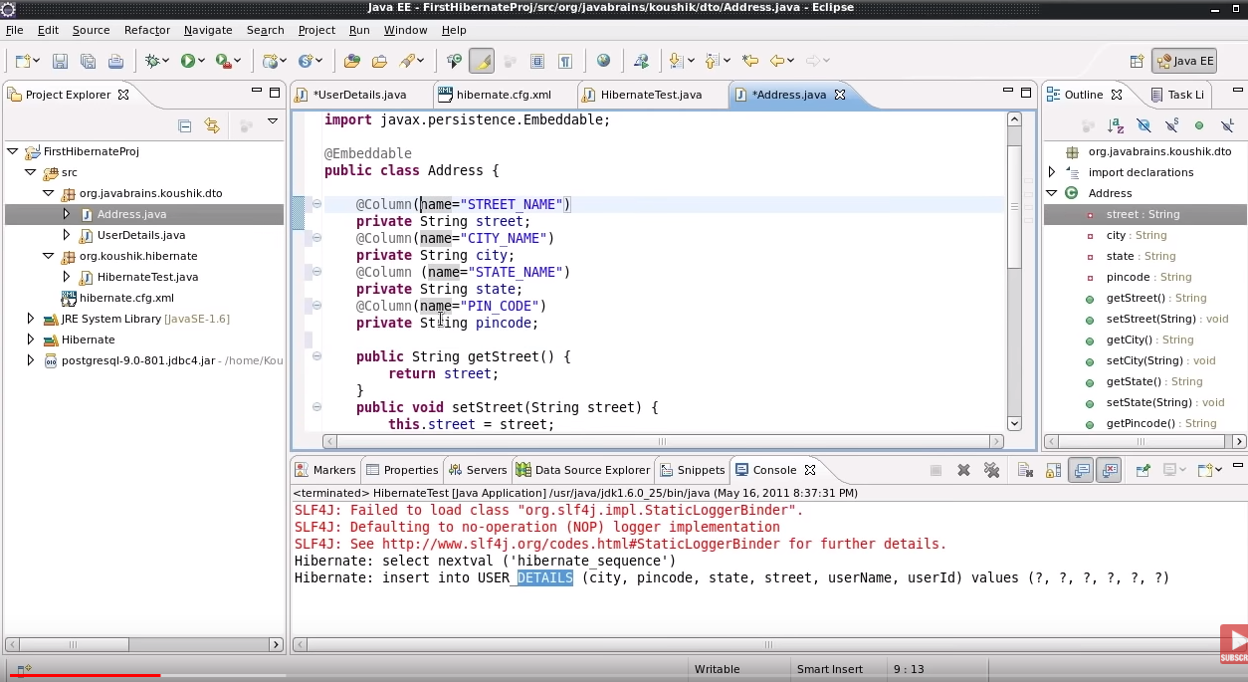

1. Or we can annotate them in the Employee Class itself as what to name them in table.

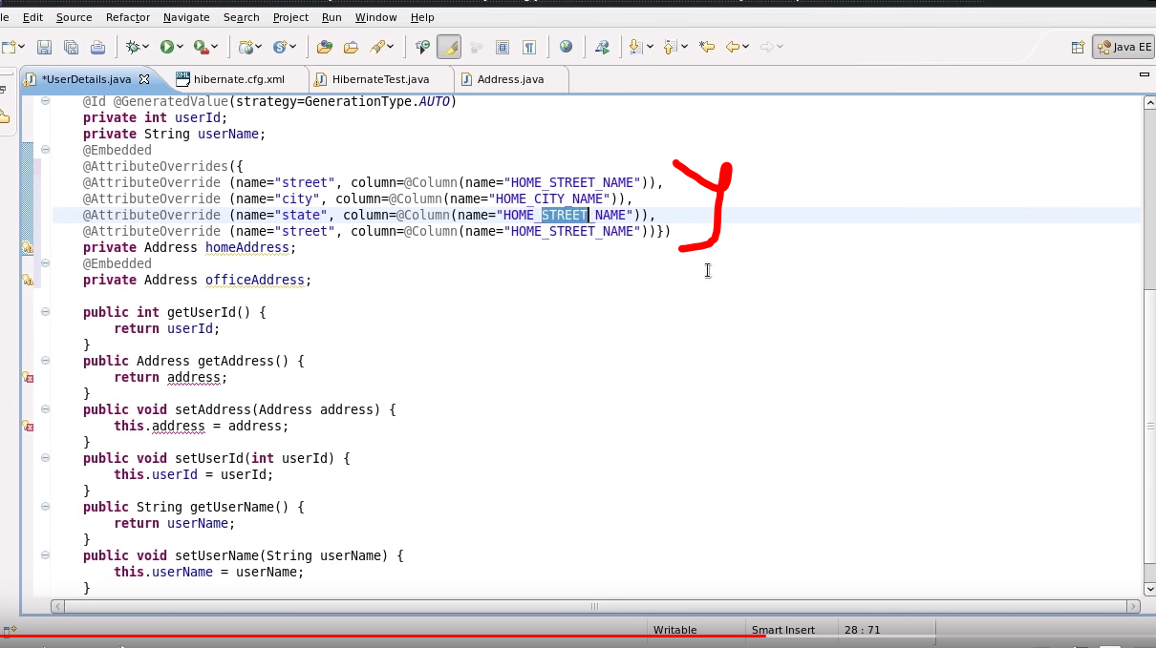

1. In order to make the PK as a complex object then use this:- and in this case we need to write @EmbeddedID annotation and we need to implement Serializable i/f to the complex key’s class.
2. 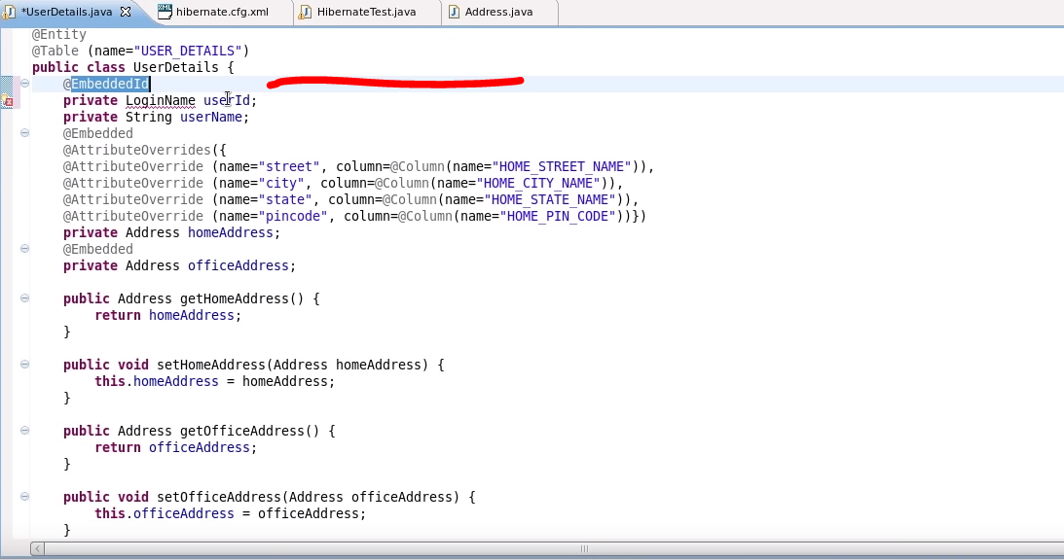

# Saving Collections

@ElementCollection is used to let know that the data we are going to persist is form of collection and

Then here it will treat “Address” as a reference var, and enter it’s PK to the USER_DETAILS as FK…

So Hibernate will treat the address table is different table and insert the pk of Address to User table as FK.

.//DONE

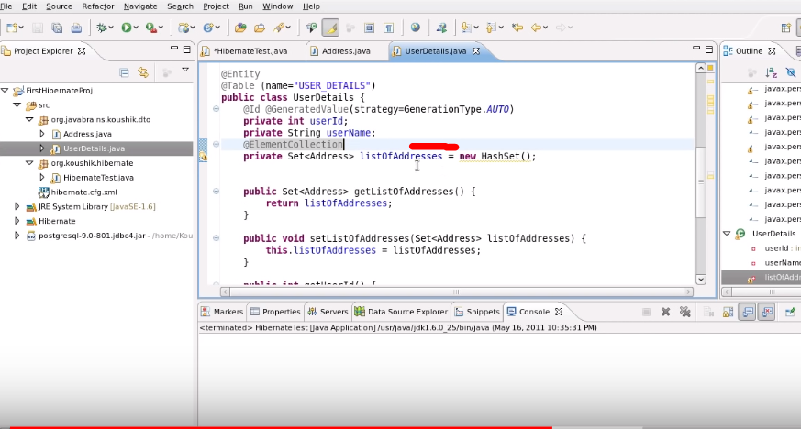

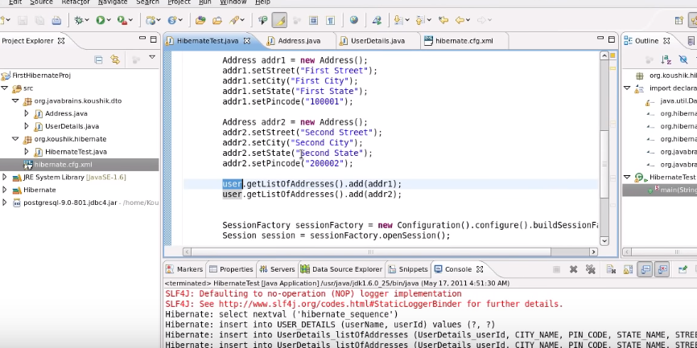

This is what we will be getting below:

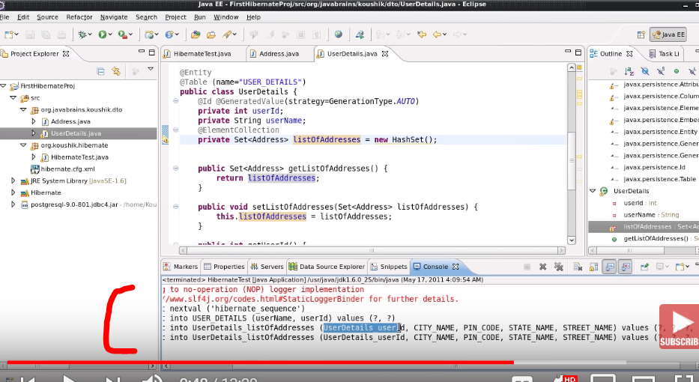

Case : Try to write this annotation @ElementCollection for a single Address instance.

Still pending

# Configuring Collections and Adding Keys

@JoinTable we can use to give name to the new table . it is optional --DOne

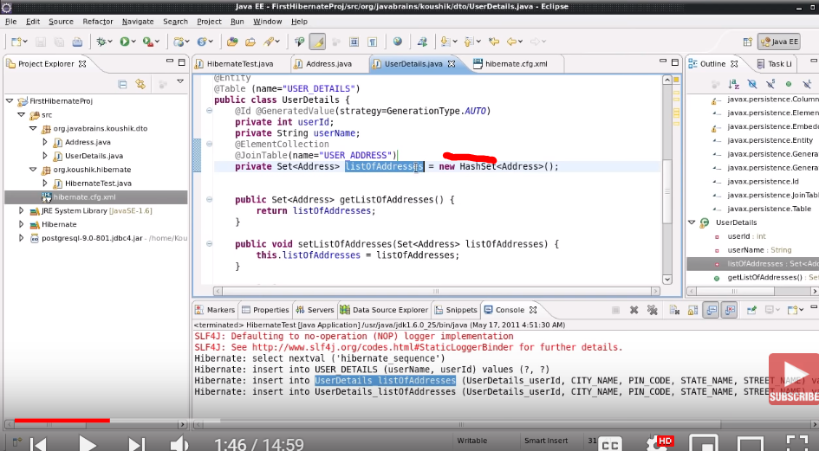

@JoinTable(name=”ADDRESS”,

joinColumns=@JoinColumn(name=”ID”)) //It is used to change the attribute name of ADDRESS table with FKs, i.e. the keys which are getting used there as a reference.

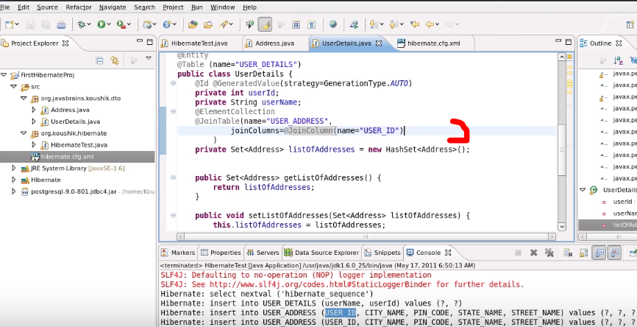

NEW TOPIC:

* We are using Indexing based Collection i.e. ARRAYLIST etc . Why ?
* Ans:--
* Here we are creating PK of address table using @CollectionID, rest of the internal comes automatically , the @GenericGenerator(name=”abc” , type=”hilo(i.e. a kind of generator)”) is used as below , in below it will create a PK coulmn as Address_id.
* @GenericGenerator(name=”sequenceVal”, strategy=”sequence”)

@CollectionId(columns=@Column(name=”ADRESS_D”) , generator = “sequenceVal” , type=@Type(type=”long”)) //DOne

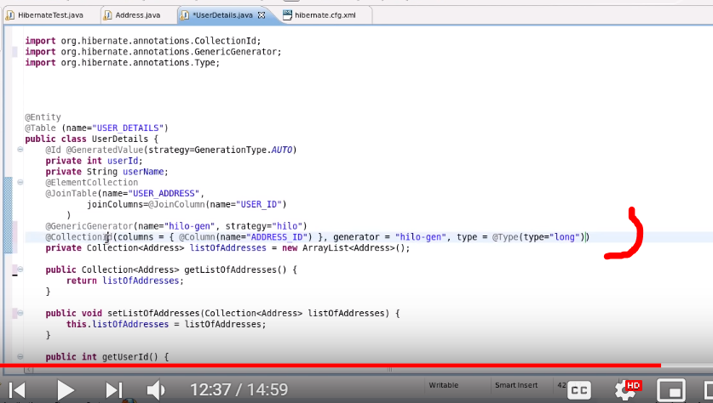

# Proxy Objects and Eager and Lazy Fetch Types

Question : In the below Highlighted area , what is it doing and will it be able to fetch the list of address and why ?

Ans:

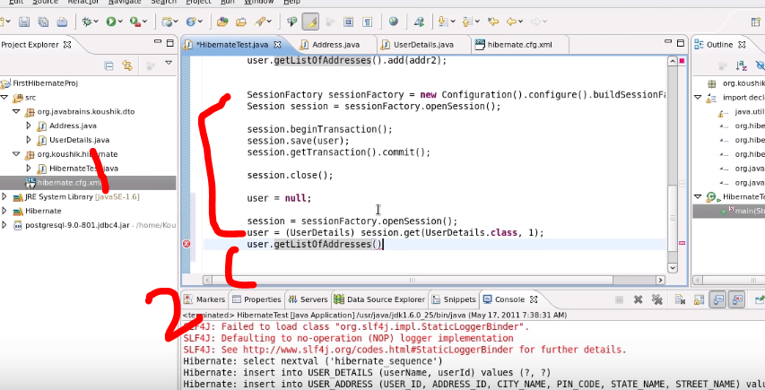

Q: What is Lazy Initialize?

A: It initialize the first level member variable. IT IS DEFAULT .

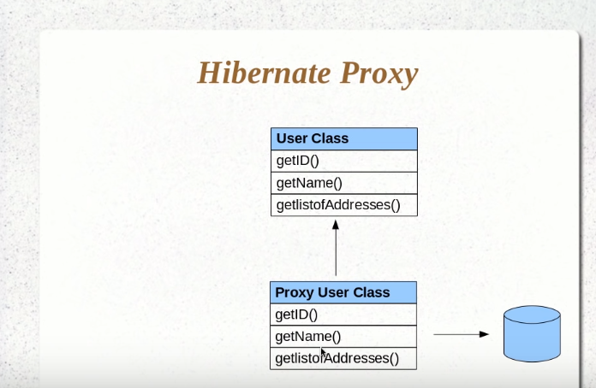

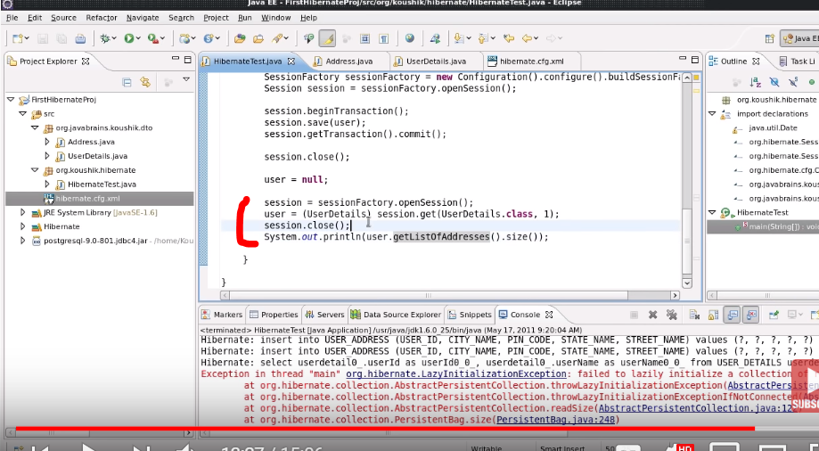

Perform the above code with EAGER ae well as with LAZY..above is lazy i.e. by default but using below SS you can work with EAGER.

@ElementCollection(fetch=fetchType.EAGER) //DONE HibernateEagerandLazyfetch.java

Theory :- There are 2 ways to fetch the data from DB using Hibernate 1- LAZY fetch , 2- EAGER fetch.

* By default we use LAZY fetch. Whenever we use LAZY fetch we a don’t deal directly with DB we use to deal with a proxy object that directly deals with DB. So incase of LAZY if you want to get an instance that is the part of you Class(Think it in the form of above UserDetails and ADDRESS), here if you want to call get() for user_details , you will be endup getting only username and other values but not ADRESS coz address will be working according to lazy fetch.. If you want to fetch Address also then call the getter of address , then in that case Proxy object having method for fetching the data from DB will be called and it will give the data back to USER_DETAILS class

To check this try to close the session then try to call the getter of Address. /// Ans here.. Ending up with LazyInit exception coz it is the session only that helps calling of userDeatils object to proxyObject to DB and vice-versa .. and this will also prove that in LAZY, get() will fetch only userDeatils value not of address. And try running the whole scenario without closing session.

* But if you provide the above annotation then whenever a get() call occur for userDetail object, you will be getting the address object too. Try closing the session and sop of address and without closing session.

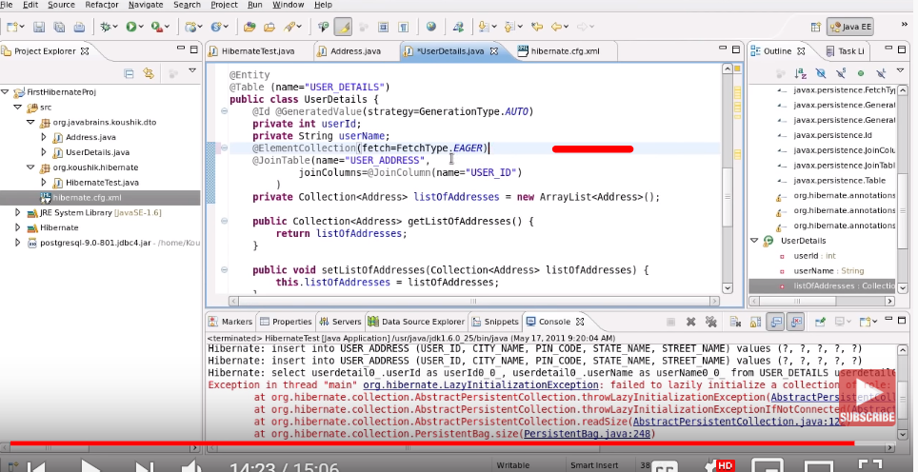

# Hibernate Tutorial 13 - One To One Mapping

Q: Difference between Entity and Value?

Ans: A hint is Address instance is value type coz with that we used Embedded and Embeddable….

Create a new Class:

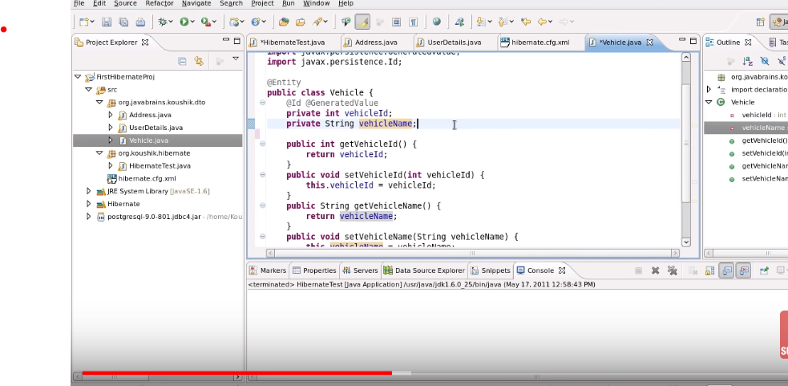

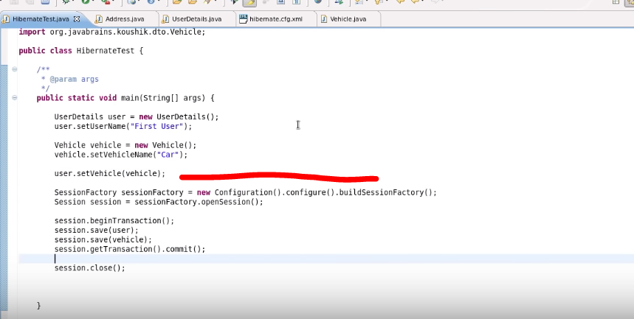This highlighted part will do the mapping… and will create a new column in userDetails table in order to map to vehicle table. FYI: Read the statements in console for better understanding.

Try using @JoinColumn.. See where you can fit ------DONE

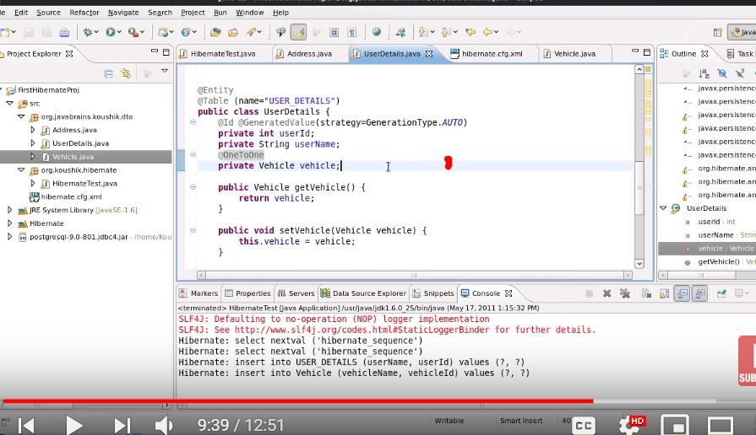

To do : Try to insert more vehicle in OneToOne. //Not Possible , later one will get Overriden

OneToOne (fetch=FetchType.LAZY andEAGER) //both done

# One To Many Mapping

Todo:

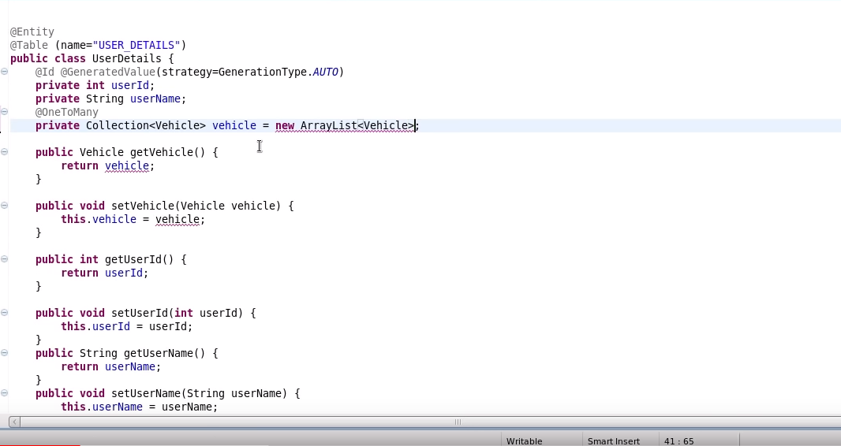

You will get

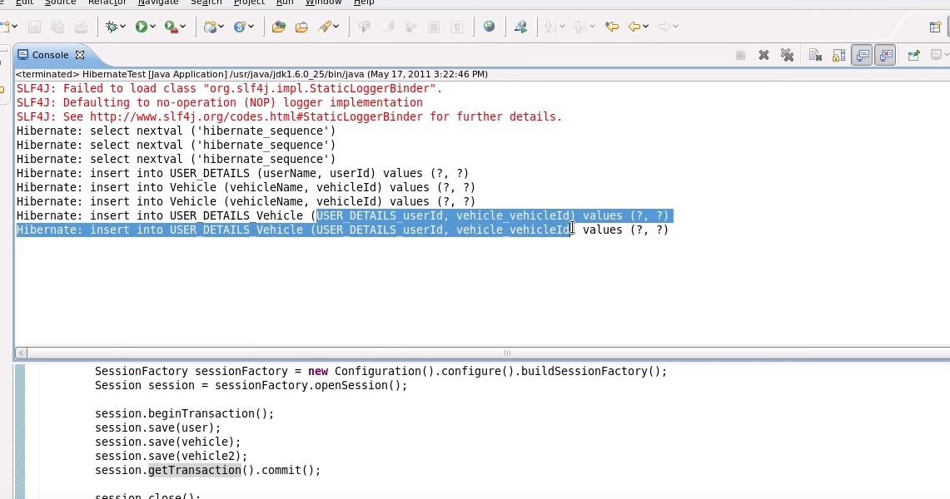

Try changing the name of Table: the new table: as below.. and try to use Mapped By

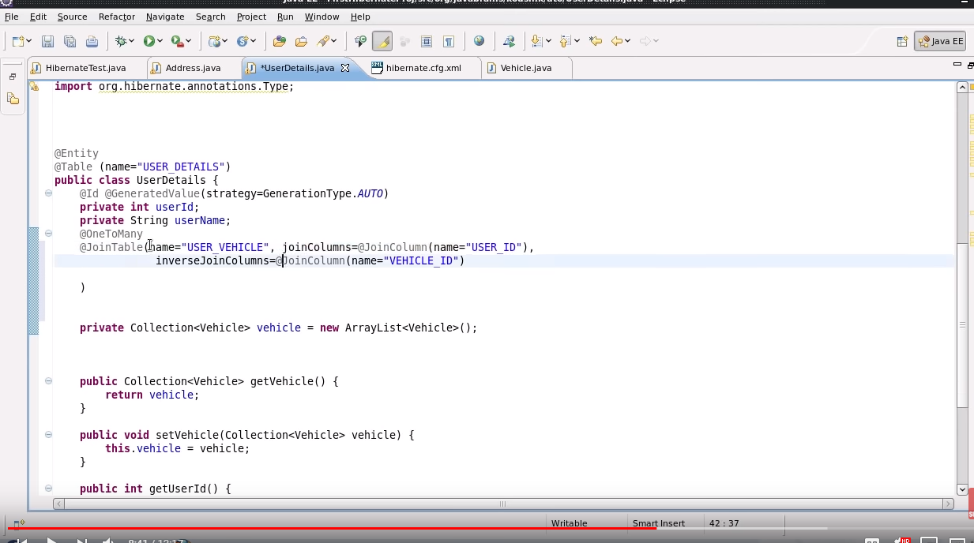

To Do :

a)Code

b)mappedBy to use: By self

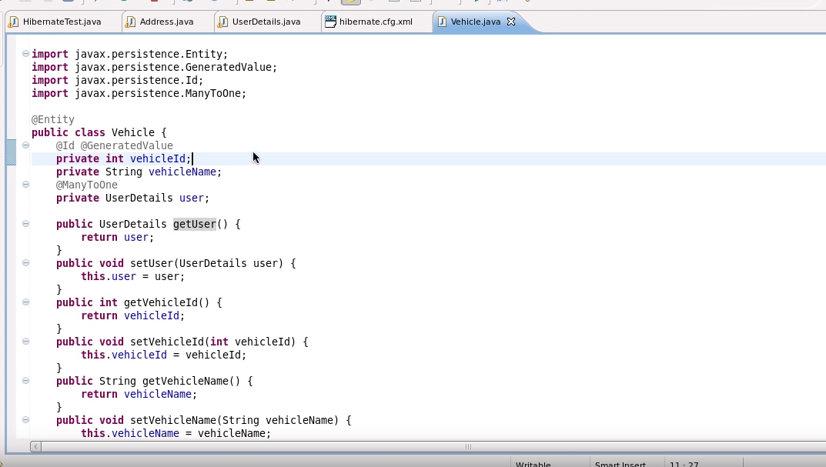

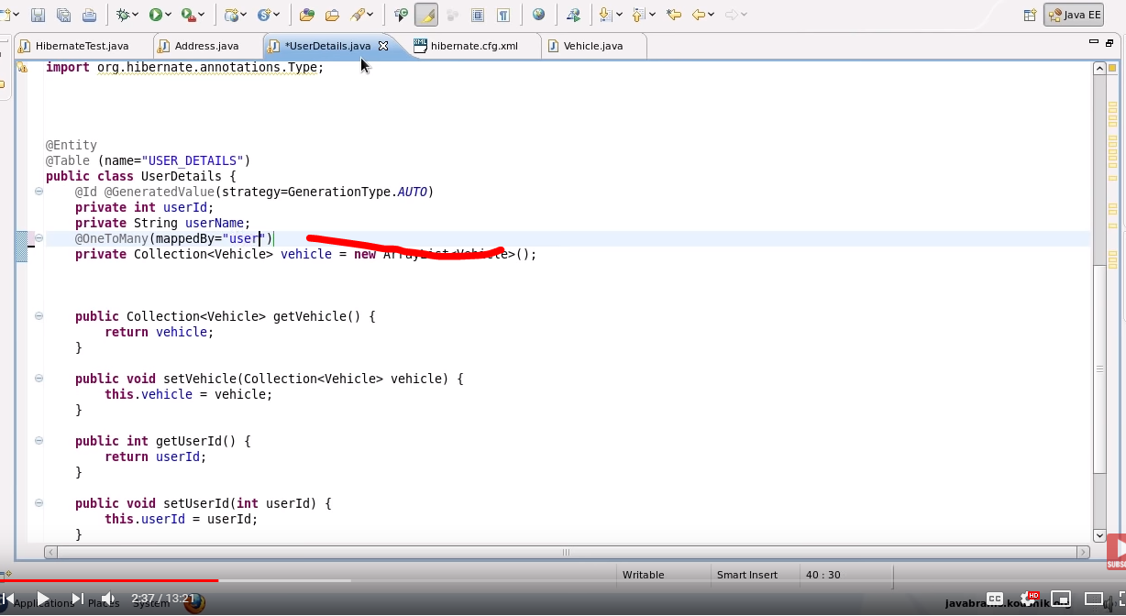

The above is using “user” instance from Vehicle class..

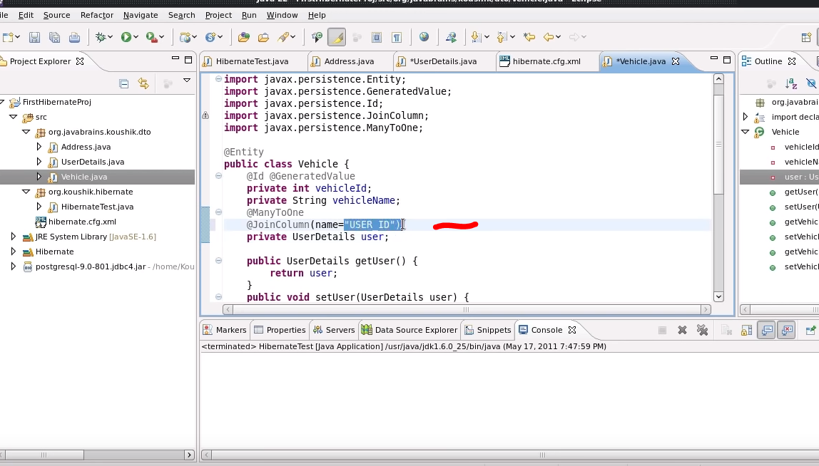

The above is specifying the new column in vehicle table to represent the userId.

NB: Won’t create a new table for showing both’s PKs.

Q: Which Class should be writing the mappedBy=”dff” , or which class should write @JoinColumn(name=”sdf”) , Why ?

Ans:

Q: Try to use Eager and Lazy in OneToOne and other.. ?

A:

Many To Many:

Main ans: Which query our code creates.

NB: in OneToMany and ManyToOne and vice-versa we need to create Collection objects for those who are referenced as Many.

ToDo:

@ManyToMany in both

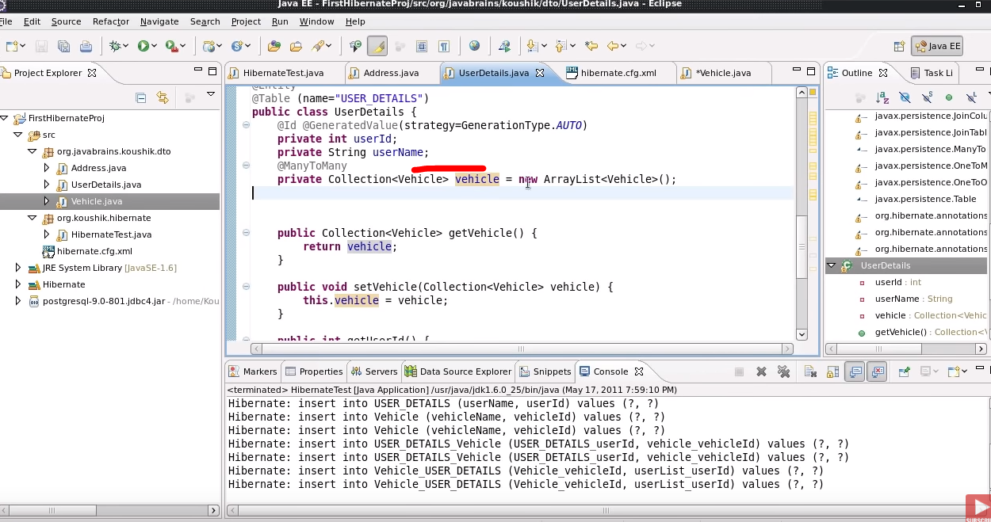

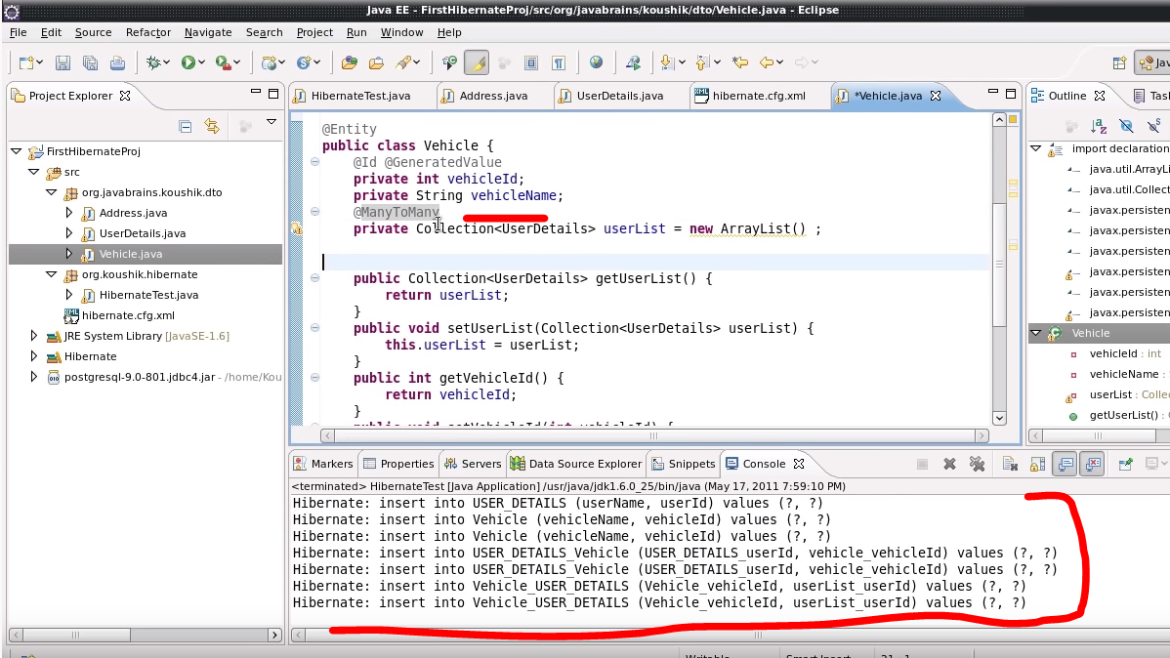

Now try doing this: it should create one extra table:

mappedBy=”abc” :- Means that the class in which it is written isn’t doing mapping and it is being mapped by the other class having ref as abc. If we won’t do this then both class will do the mapping and will create 2 new tables.

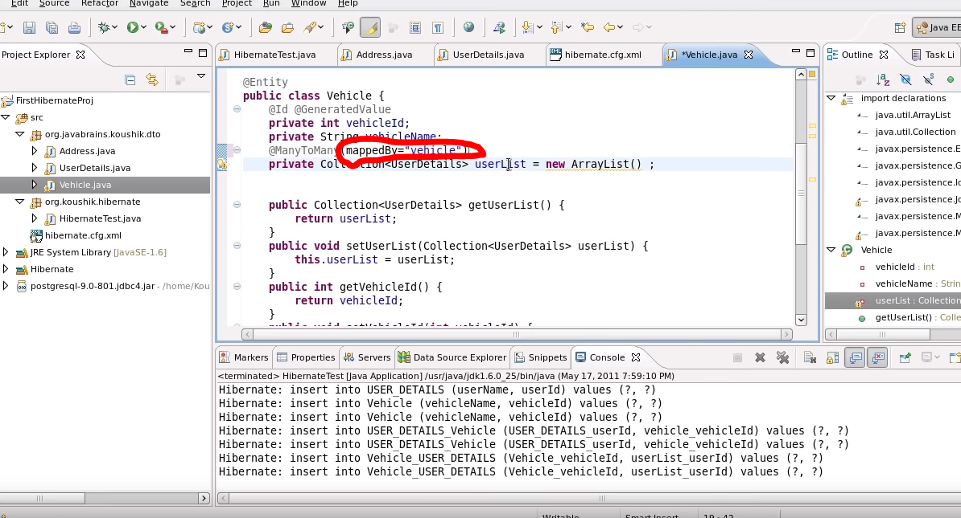

**Cascade Type and OtherThings.**

ToDo:- The below @NotFound is used incase the vehicle doesn’t have any owner then to ignore the exception.

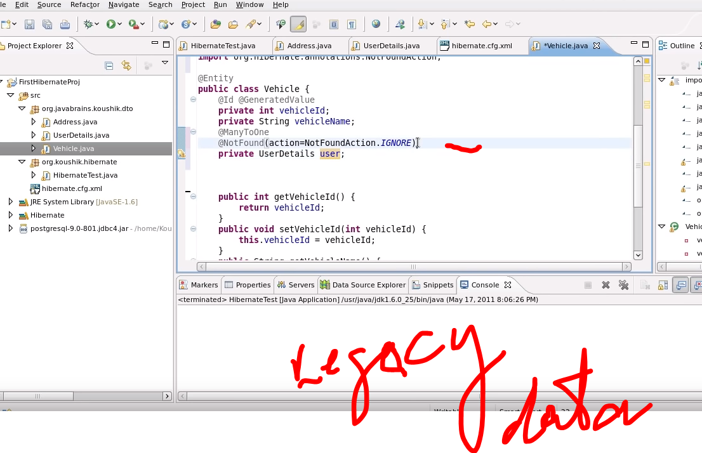

* HibernateCollections: Impo.

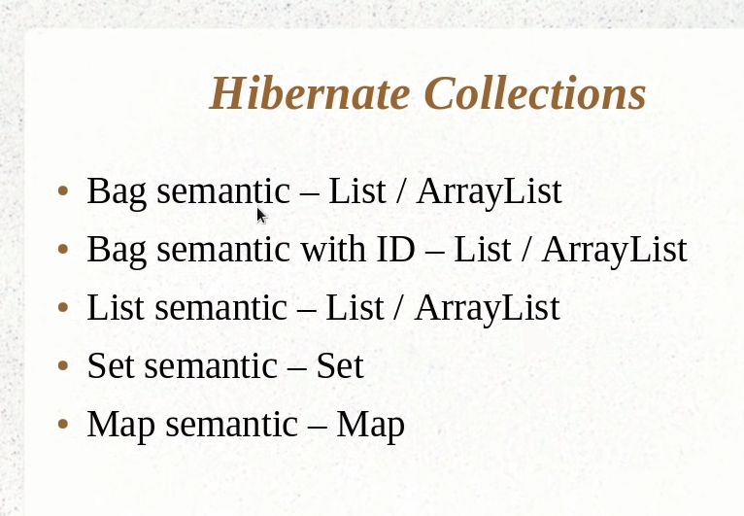

* Way to avoid below redundant code to persist every object: Use Cascade

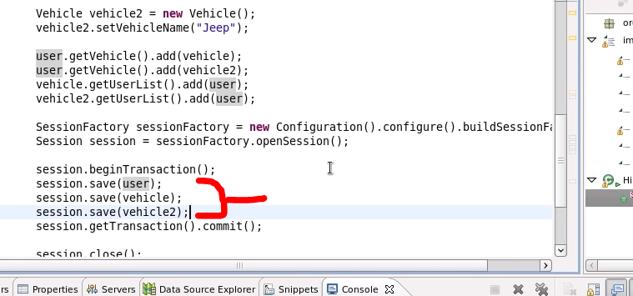

* Use @OneToMany(cascade=CascadeType.PERSIST) for that and look for others too.like below : and write sessin.persist(obj).

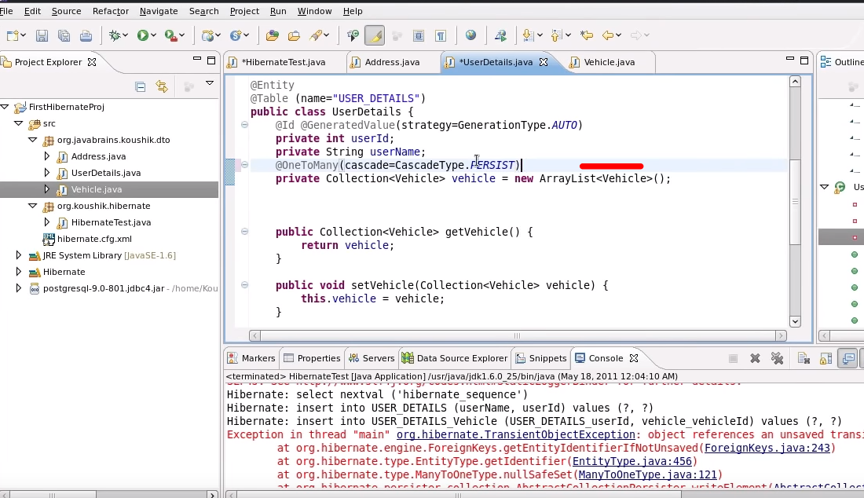 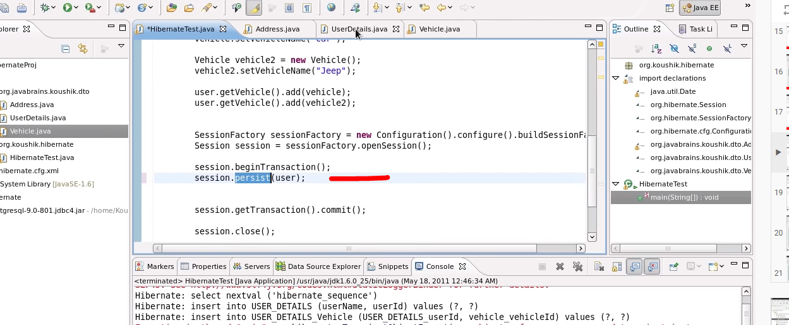

Q: Difference between save and persist?

A:

IMPLEMENTING INHERITANCE:--

Why ?

A: We use inheritance in Hibernate to fetch the data from the sub-class’ table by using polymorphic querying the parent’s class.

Entity **inheritance** means that **we** can **use** polymorphic queries for retrieving all the sub-class entities when querying for a super-class. Since **Hibernate** is a JPA implementation, **it** contains all of the above as well as a few **Hibernate**-specific features related to **inheritance**

4 Types:

1. MappedType class:- In this parent class can’t be entities.
2. Single Class:- In this all the super, sub class will be the part of single table, no other table required (DEFAULT IMPLEMENTATION) **Hibernate needs a way to differentiate between them.**

**By default, this is done through a discriminator column called *DTYPE LEAST NORMALIZED***

1. Joined Table:- In this each class has its own table and querying sub class require joining queries to get data.
2. Table-per class:- In this each class has it’s own table having all of its own property.

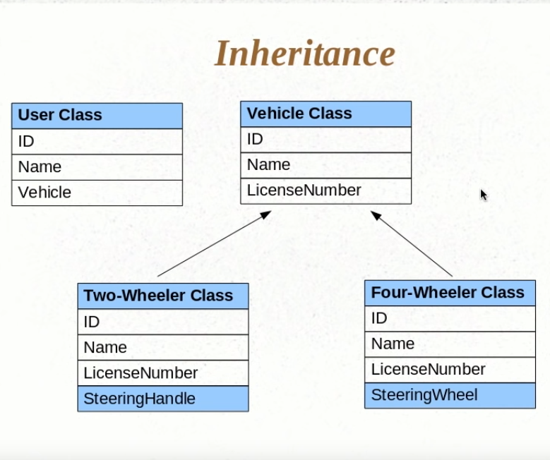

* Let’s say we have a user with id and Name and a Vehicle instance that we need to persist. FYI Vehicle class having 2 sub class as Two Wheeler and Four Wheeler. So at run time we need to decide that which object user will select (2 or 4 wheeler),we can’t have a FK relation with both ,otherwise it would be tricky to decide either 2Wheeler or 4Wheeler , so better to go for Vehicle.

Another benefit is if we need to add some property in both of the table better to add it in Vehicle class.

* Below we are creating child of Vehicle as 2 wheeler and 4 wheeler

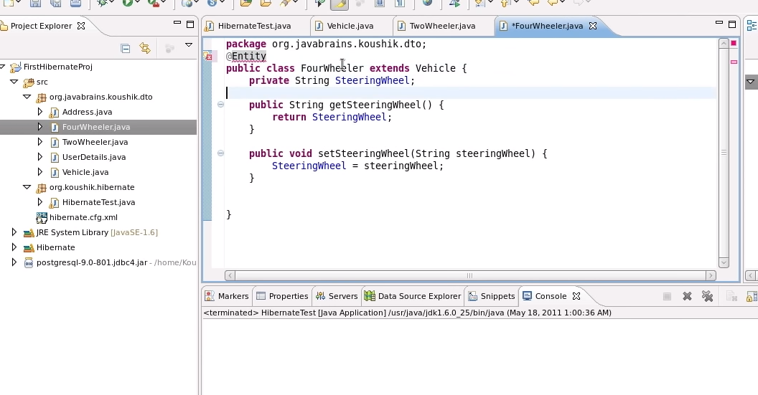 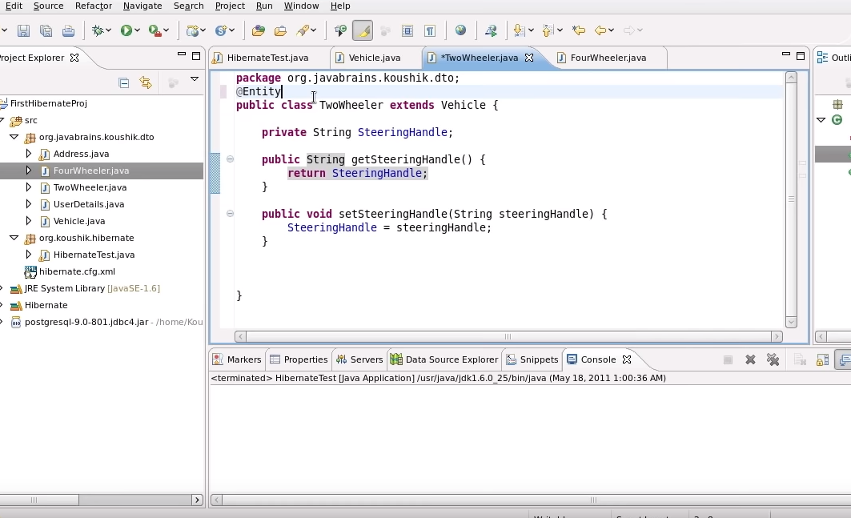

* In case you create Child class of vehicle class as 2Wheeler or 4Wheeler , try to save them only in DB, Hibernate will not create extra table for them coz hibernate by default works on a Single Table Strategy. A lot more strategy to come.

To change the type of descriminator:

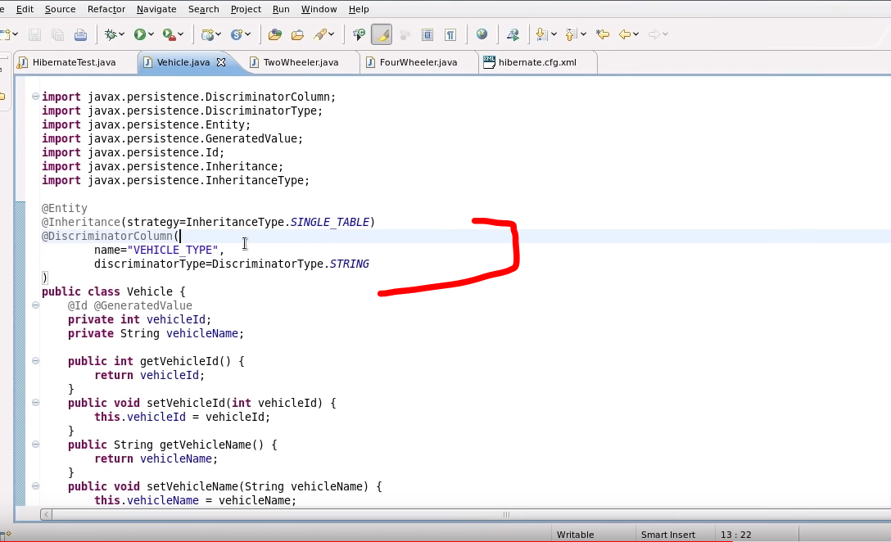

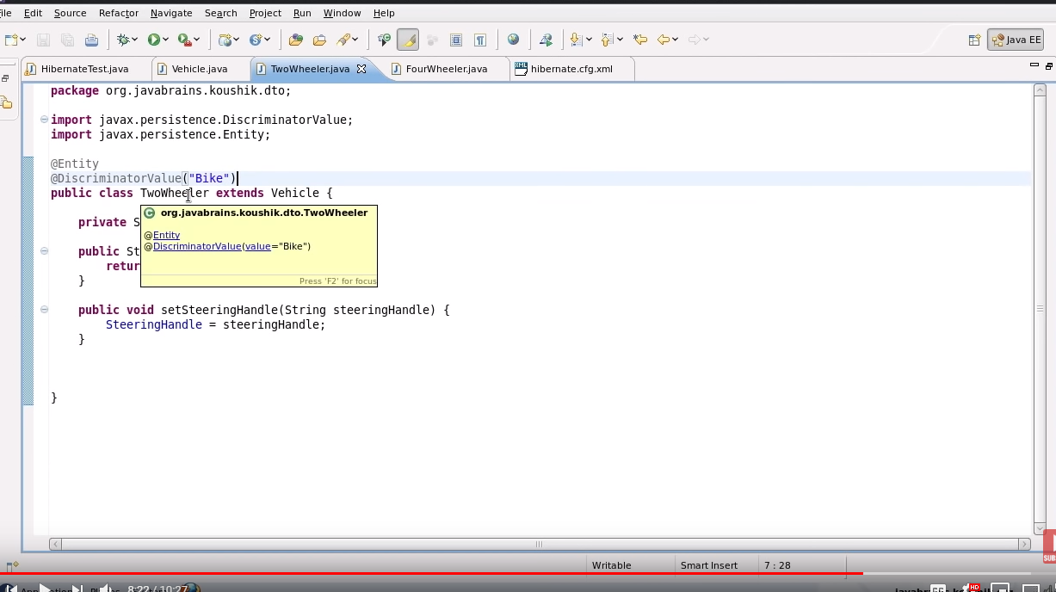

As above do the same for 4Wheeler and then save().

# Implementing Inheritance With Table Per Class Strategy

* In this @DescriminatorColumn is not required as each class has it’s own table.
* Need to remove @DescriminatorValue from 2Wheeler and 4 Wheeler class too.

Need to do this change only:

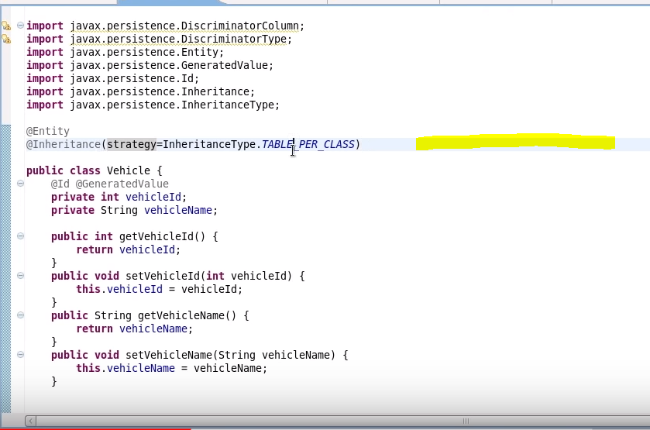

And save().

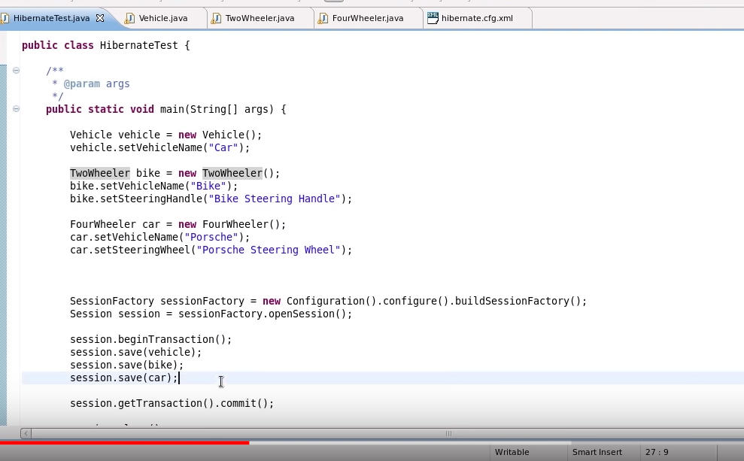

# Implementing Inheritance With Joined Strategy

* In this strategy the tables are formed in such a way that it’s data can be extracted using JOIN.
* The data from the parent table doesn’t go to the child table.

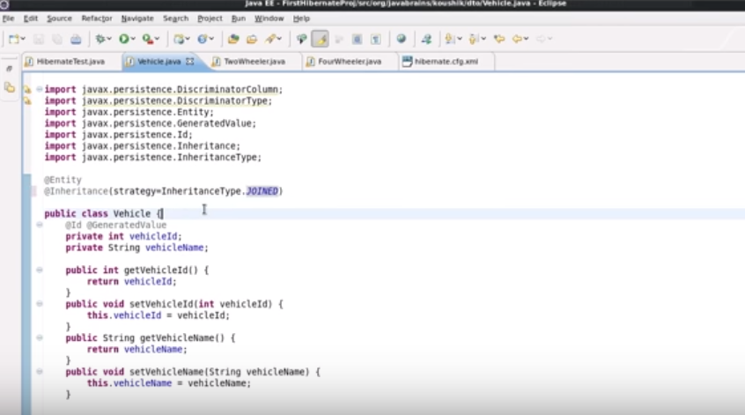

# CRUD Operations

We will be working over a single userDetails Object:- Just to analyze the simplest way…

1. Insert:

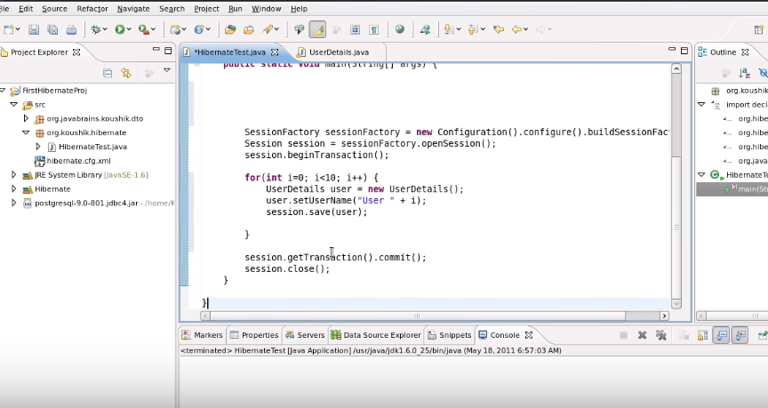

1. Select :-

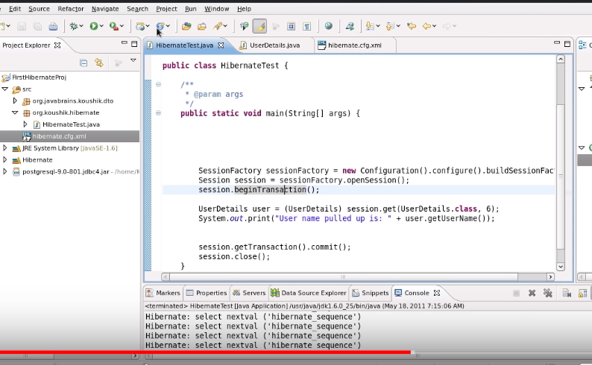

Delete:

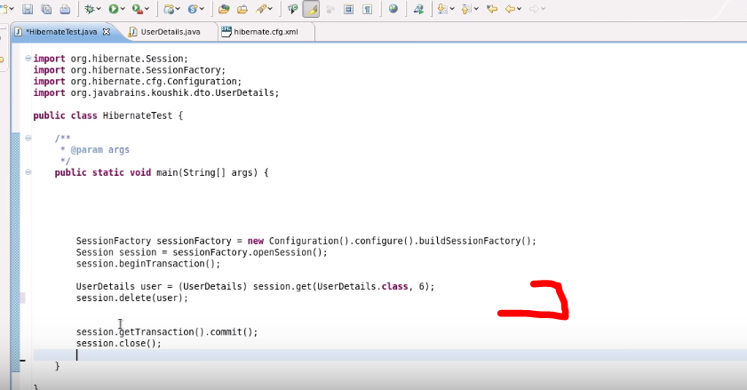

Update:

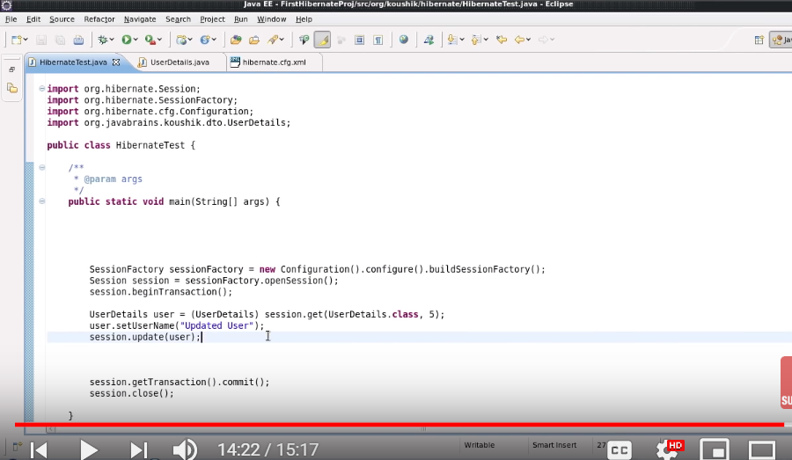

# Transient, Persistent and Detached Objects

Transient: In the below Snap if we don’t pass the userDeatil’s object to session.save() then this userDetail’s object will be called as transient Object.

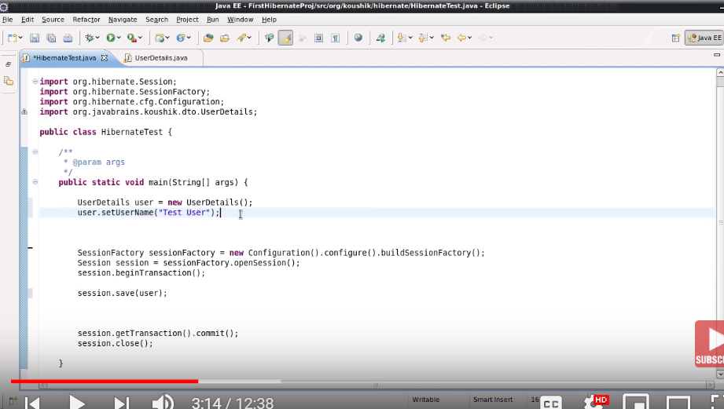

Persistent: In the above snap if we pass the object in session.save() then that object will be persistent object..

* In the below Snap shot first a insert statement will run and then user.setUSerName() will run the update option .
* What ever be the last stmt would be the last state of the database.
* If in below we tryna run update the user 2 or 3 times hibernate will run the update once only and will update it as per the last stmt.
* Once the session is closed that object will be called as detached object.
* Difference >- In case of transient the object is not even tracked by hibernate. As we didn’t provide It in save().

Where as in case of detached the object was tracked by hibernate and after closing it will not be saved, here we pass the object to save()

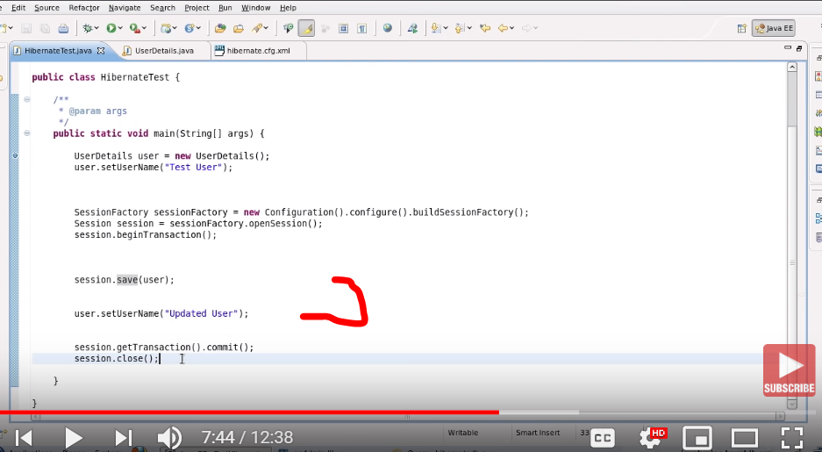

Understanding state Changes :-

State 1:

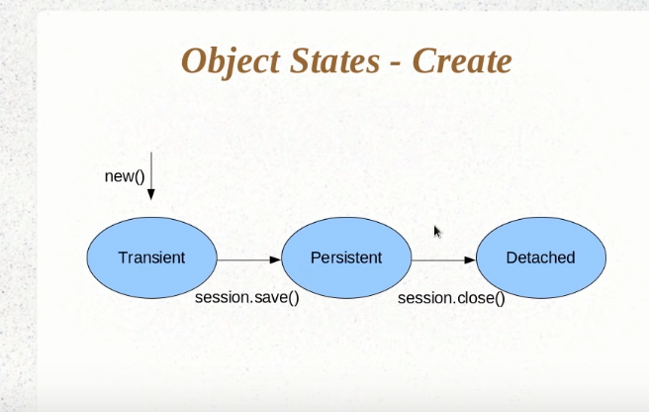

State 2:

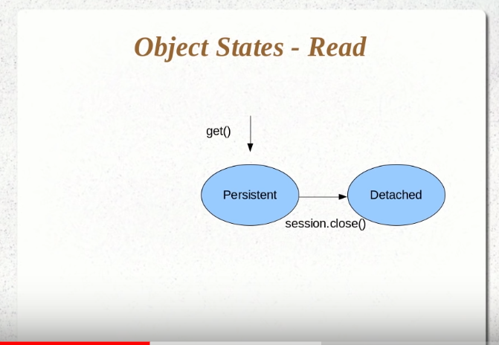

State 3: Will be a combination of 1 and 2 state

State 4:

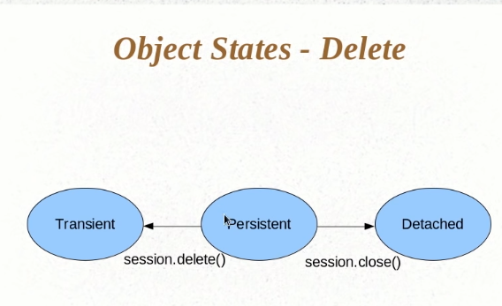

Detached to persistent:

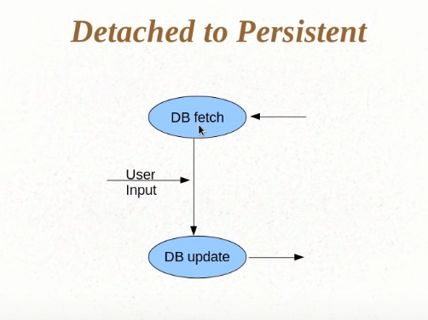

Code To:

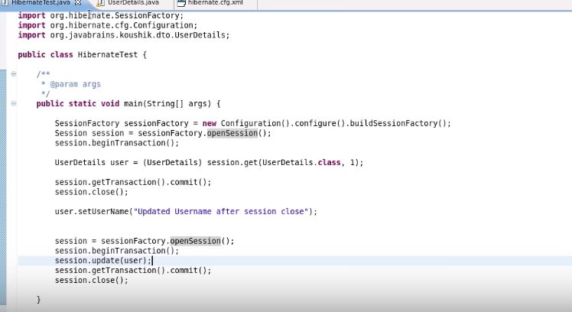

And by using below Annotation : Whenever you try to update a data which is extracted from DB, hibernate checks if any change is made in the object from DB then onky it will run the update query otherwise not. (try to do both .. update a user and don’t update the user)

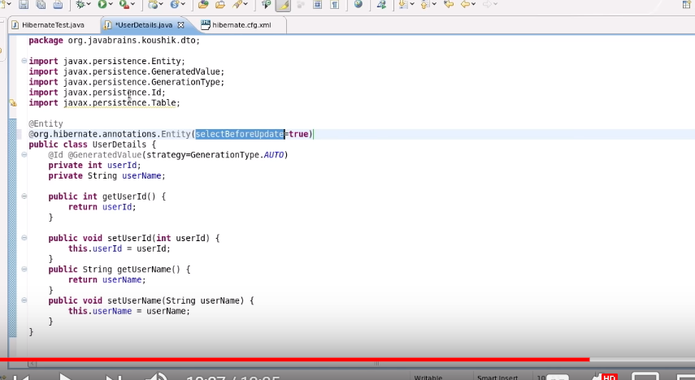

# Introducing HQL and the Query Object

SQL talks in terms of tables and HQL talks in terms of Object.

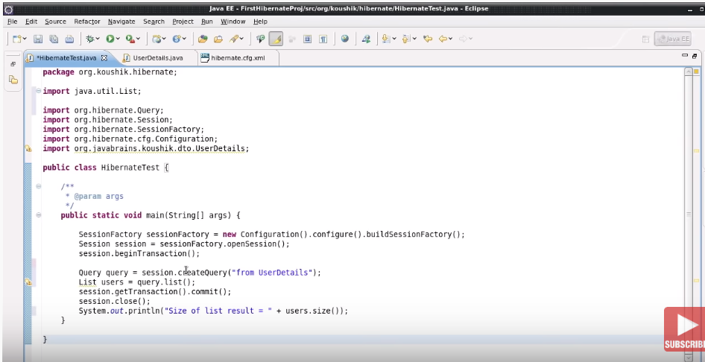

* As below SS , this is how we write a where clause:

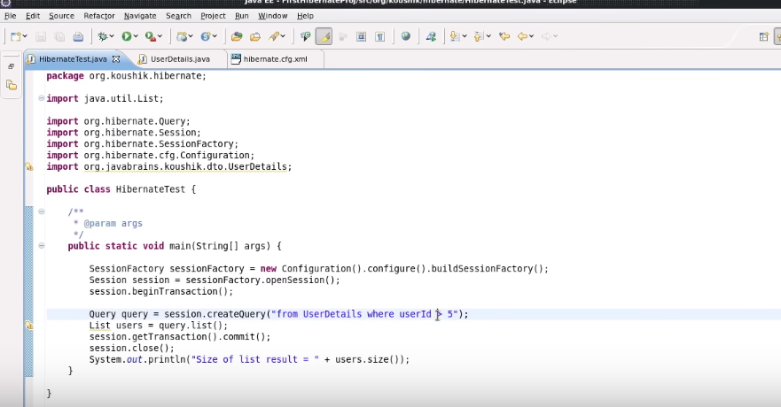

Using query.setFirstResult(int x);

: Returns the value after x from userdetails.

Using qry.setMaxResult(int y): decides the number of result object from db i.e. y

->

Below will give the data only for username:

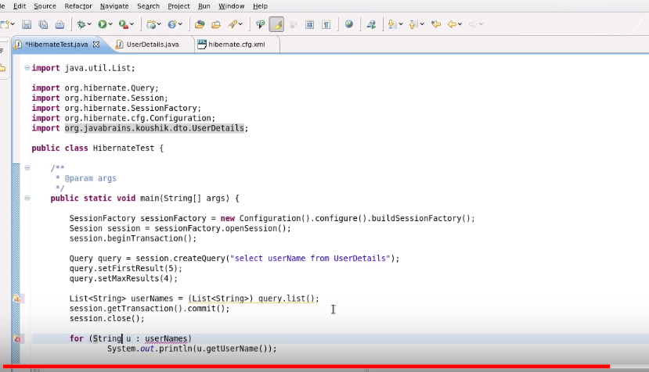

* Try doing the below as well , coz it will give the data in the form of a MAP.

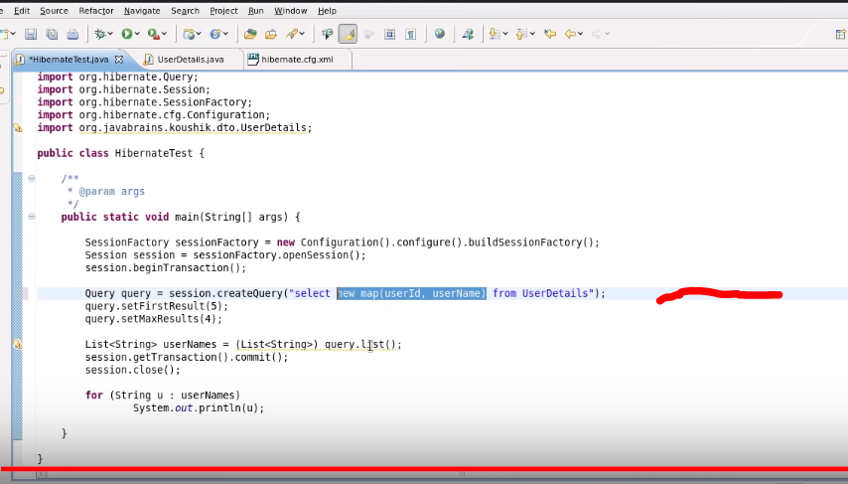

* Select max(userId) from userDetails.will also work

# Understanding Parameter Binding and SQL Injection

* Below SS is for sql Injection which is not so recommended as its not safe.
* 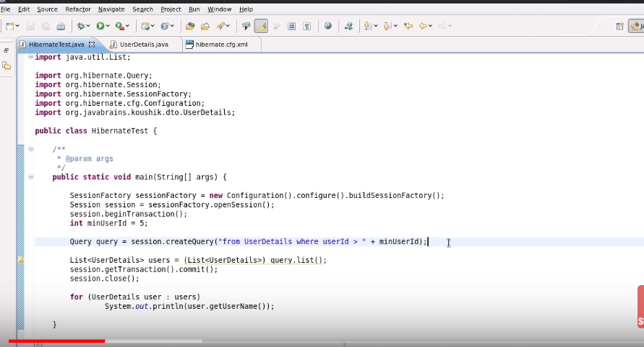
* To remove this parameter binding is there.
* 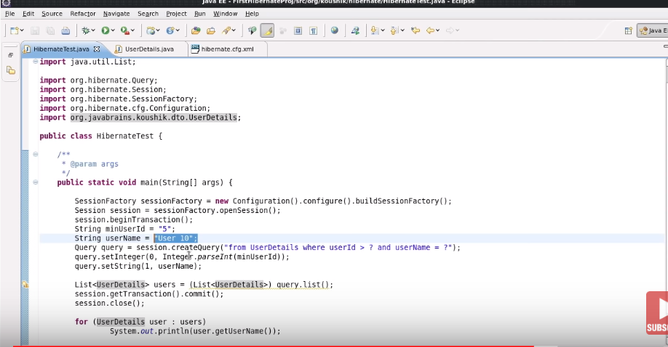
* 2nd way : 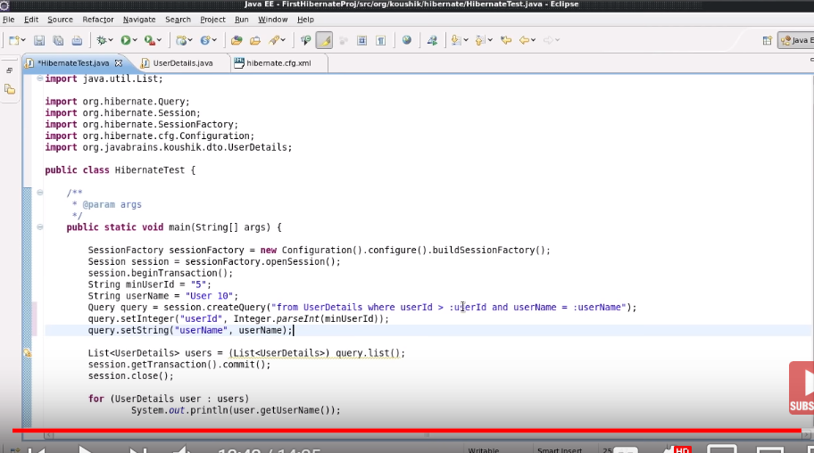

# Named Queries

Step 1:

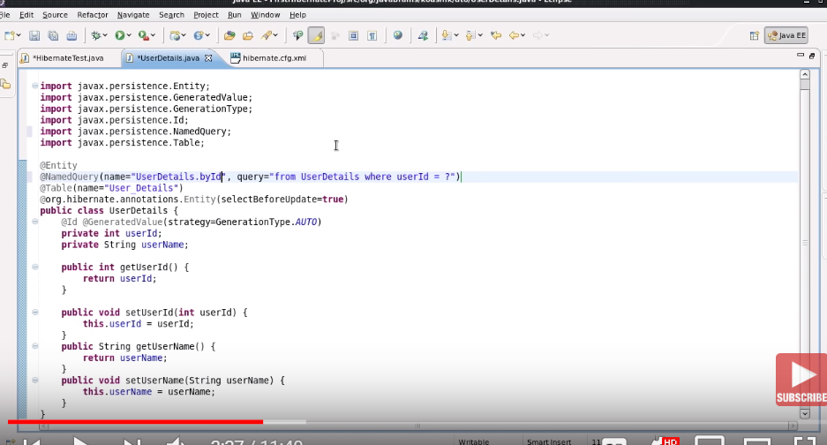

Using Native query:

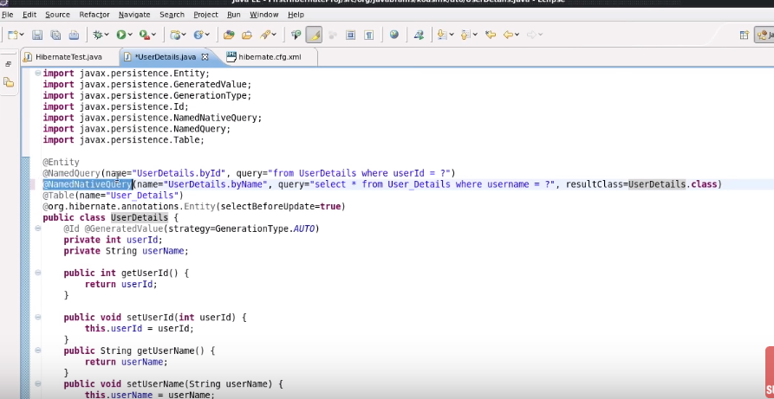

Step 2:

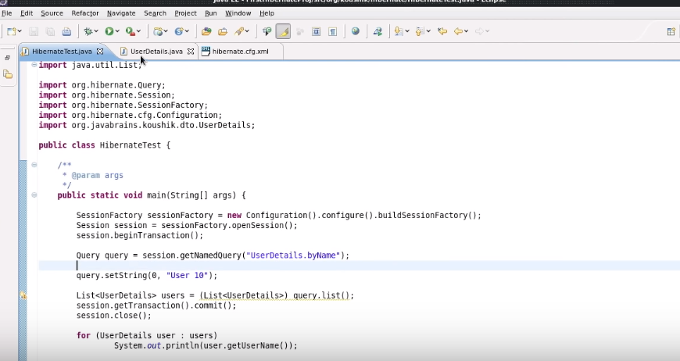

Criteria API:

* Actually, used to reduce the pain of where clause conditions: - instead of adding where clause we can use Criteria object.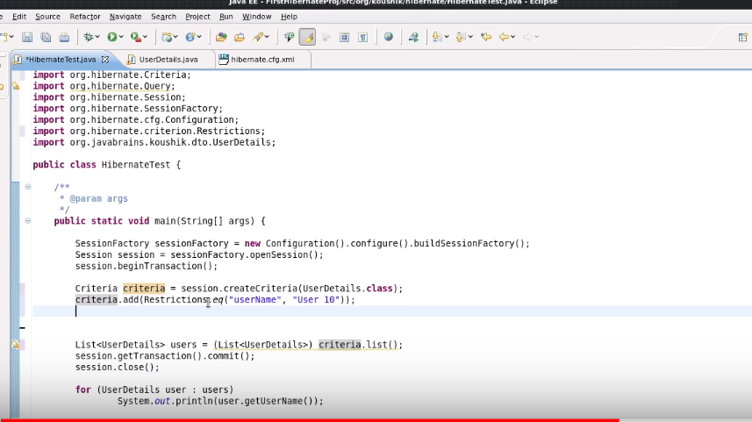
* Instead of “eq” we can use other conditions too.

# Understanding Restrictions

Case 1:

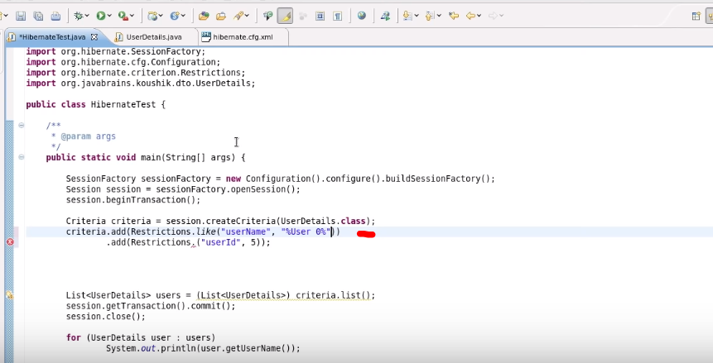

* Below can be used for OR condition:

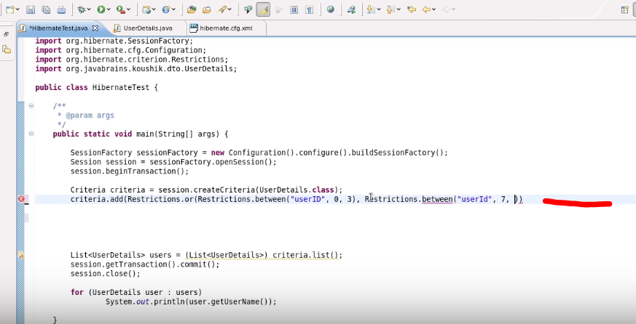

# Projections and Query By Example

* The below is used for getting all of the userId and for these further we can use max() and other functions too , using Projections.max() etc.

Case 1:

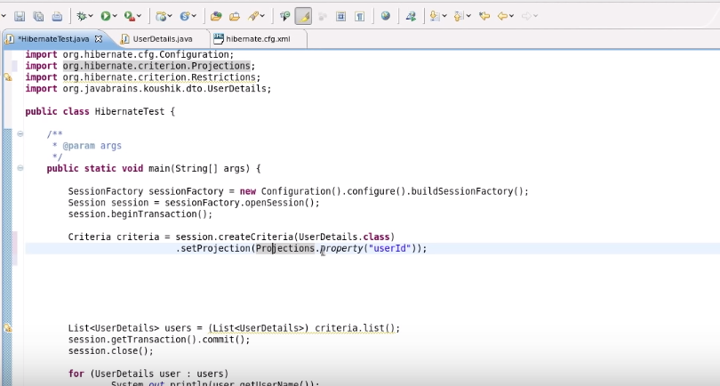

Case 2:

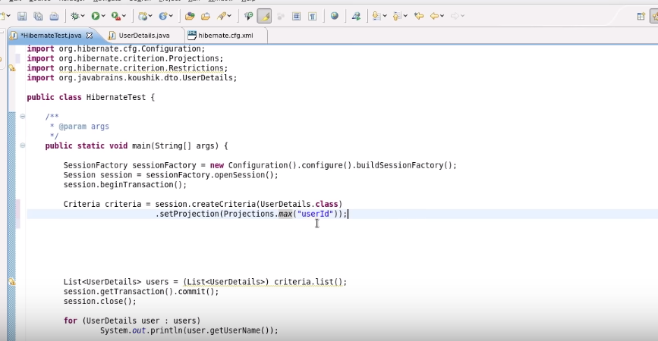

* In QueryByExample , hibernate skips things:

1. It skips null.
2. It skips PK.

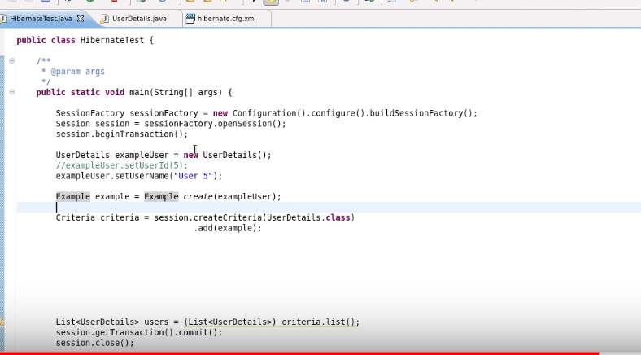

Case 3:

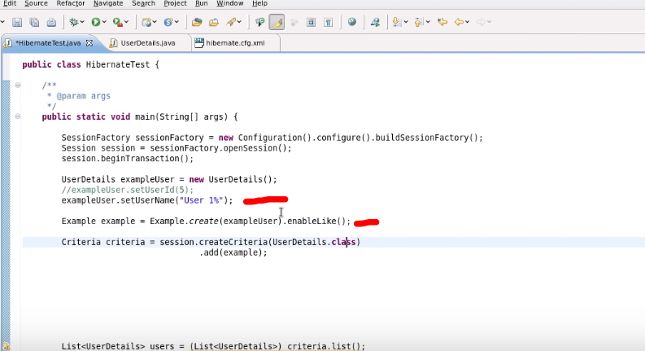

# Cacheing in Hibernate

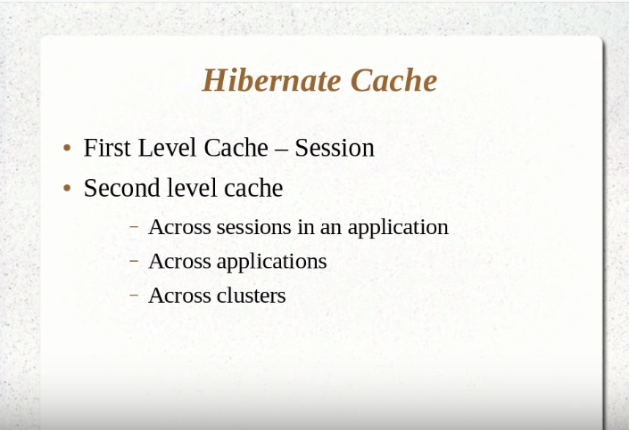

Code for every Snap in this topic:

First Level Cache-Session :-

1. Case as in which we run update 2 times in a session opening and closing.
2. Case as in hibernate detects that there is a select qry ran and after that no change in the data happens it won’t run update then even if update is called.

* Below is the good example of Session – level cache ,as we are trying tofetch data from DB twice but the select qry runs once as there is no change happened in the DB regarding the object.

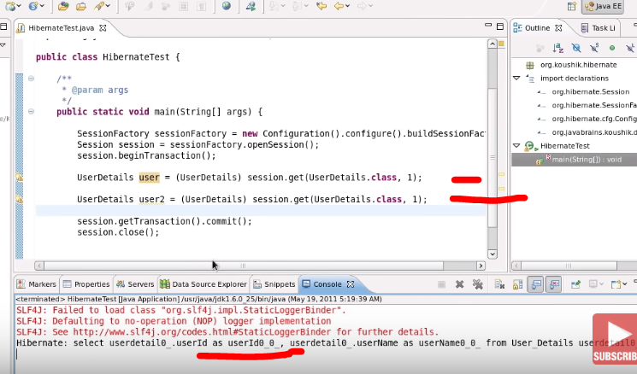

* In the below SS there is no select qry runs again coz the updated data is in the session cache.

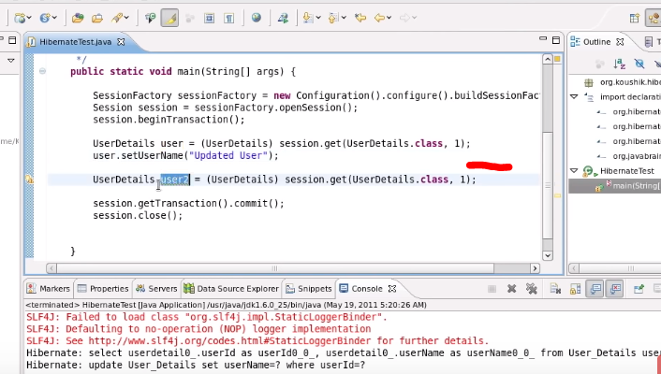

* Try to run the user2 extraction in another session then will be getting 2 select calls from db .

In 2nd Level cache 2 sessions can talk to 2nd level cache and in case of 2nd level cache .. user2 again need not to hit the db it will get it from 2nd level cache.

# Configuring Second Level Cache

Actually hibernate’s cfg file has a tag as property with name=”cache.provider.class” with default value “org.hibernate.cache.NoCacheProvider”. on basically disables the 2nd level cache , so in order to enable the 2nd level cache just go to “org.hibernate.cache”

and select some different cache class.

**Hibernate second level cache** uses a common **cache** for all the session object of a session factory. It is useful if you have multiple session objects from a session factory. SessionFactory holds the **second level cache** data. It is global for all the session objects and not enabled by **default**.

Step 1: The below highlighted area disables the second level cache.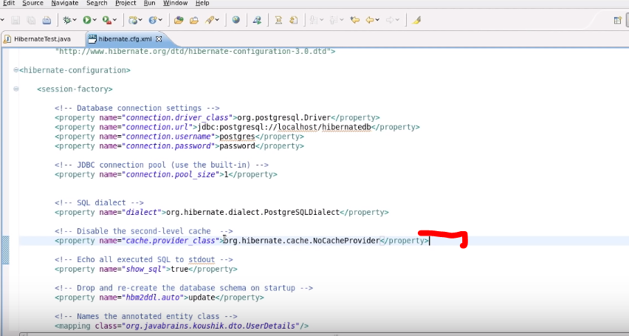

Step 2: Change the name of the cache provider and enable the 2nd level cache.

Download EhCache jar and add it in to the classpath.

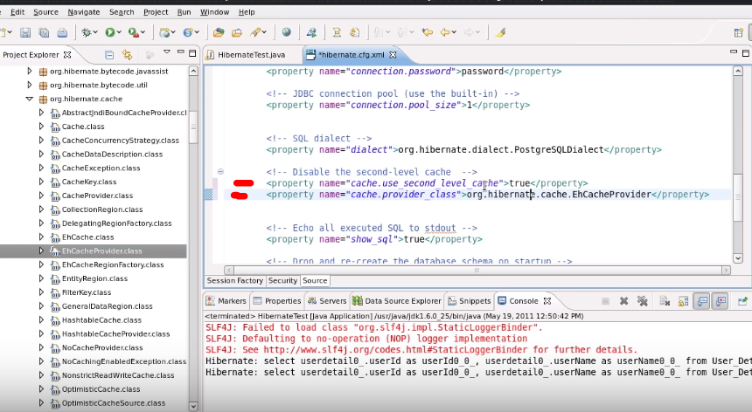

Step 2 next part: Use below jar

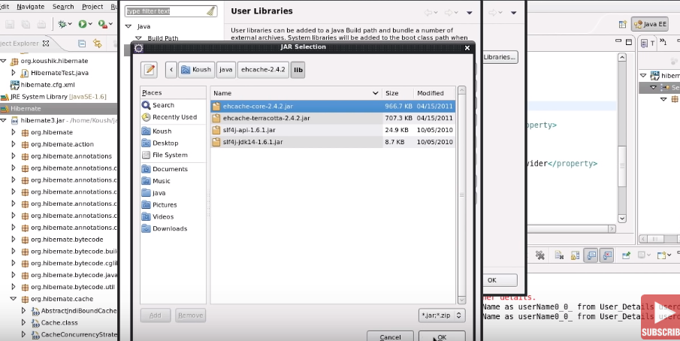

Step 3: then we need to configure the entity that we need to be cached.

@Cacheable ; used to let hibernate know that the given “ENTITY” must be cached in 2nd level cache , I have highlighted this as in further go there is a condition where we can make a query as cachable.

@Cache(usage=CacheConcurrencyStrategy.READ_ONLY) --- you can use any strategy.

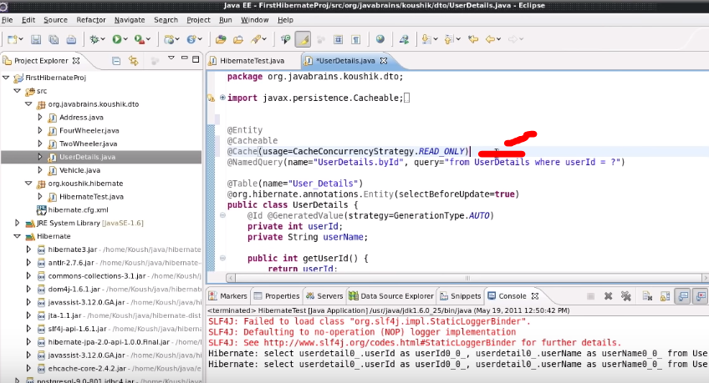

Step 4: Run the below and observe the no. of execution of select statement.

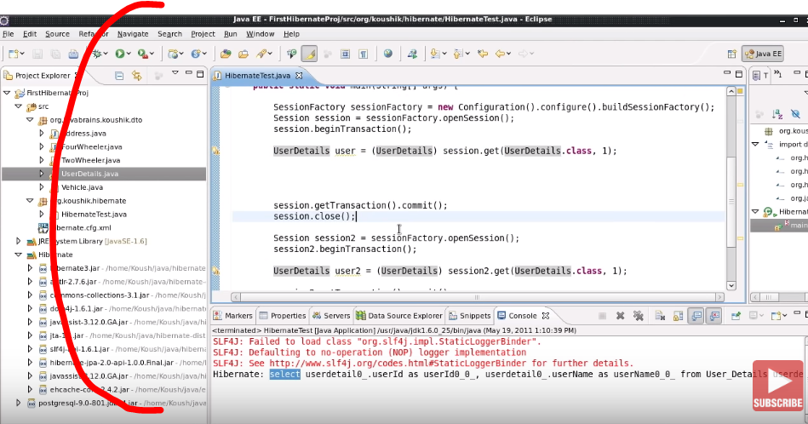

# Using Query Cache

Q: In case of session.createQuery() , how many queries will run ?

Ans:

Look below SS.

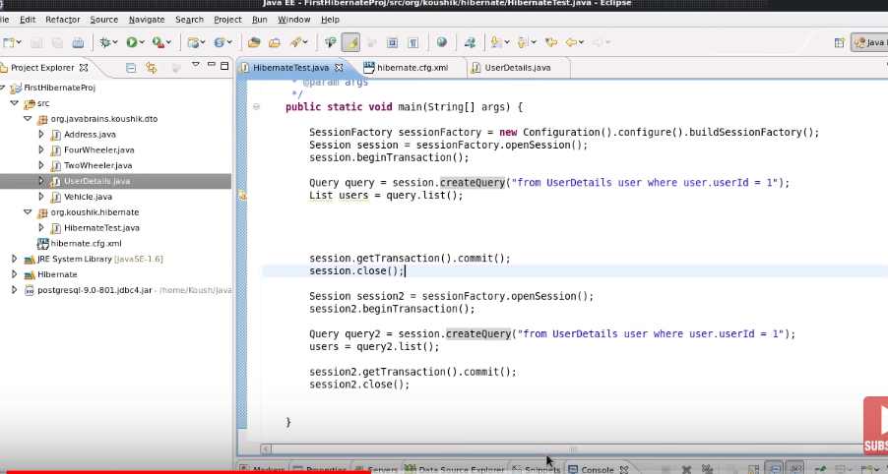

Ans is :

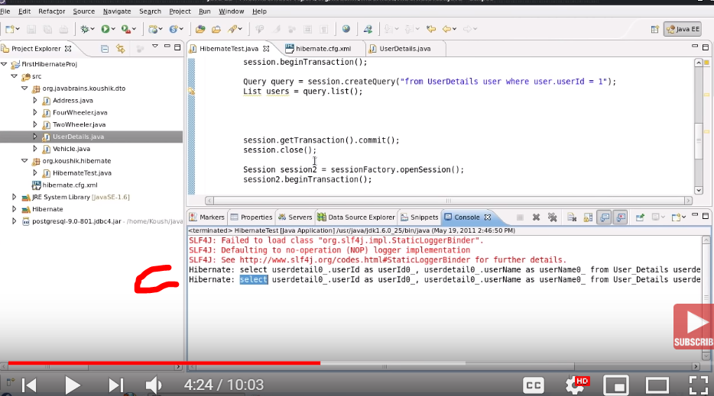

So for this if we want to save the data in 2nd level cache while querying the table then we need to configure it also that we need to define a query cache there just like below:

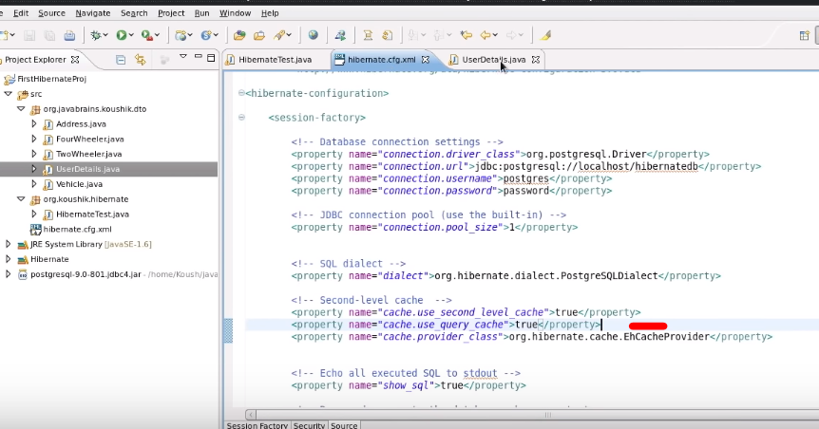

And enable the caching at query level too like this and we need to do both changes otherwise again 2 select will be there:

As this setCacheble tells to look to the query cache first then go to the DB.

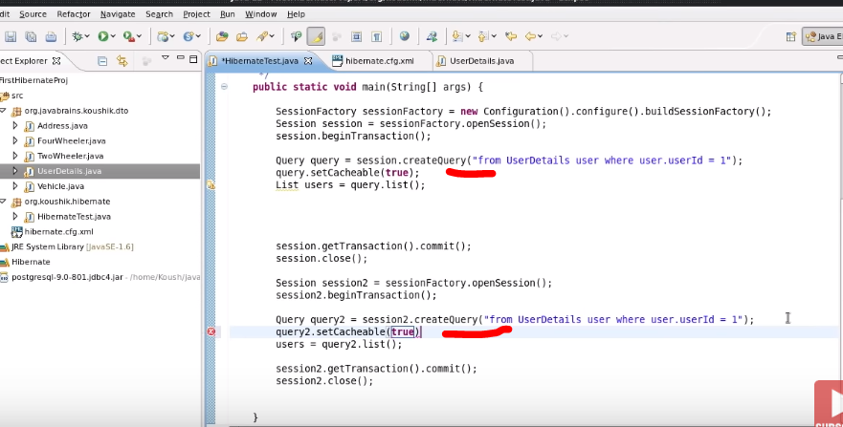

So, actually we have 3 caches:

1. Session level cache.
2. 2nd level cache.
3. Query level cache.

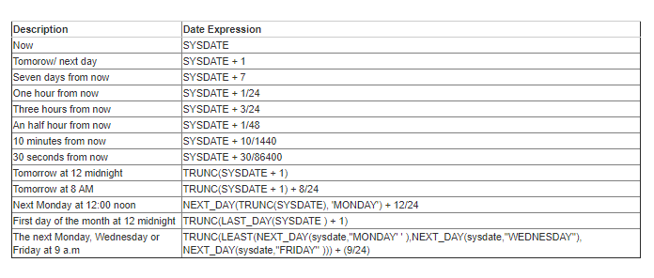

* add_months(sysdate,1); e.g. select add_months(sysdate,-2) from DUAL;
* select * from device_protection_vendor order by 1 asc fetch first 2 rows only;
* select * from device_protection_vendor offset 1 row fetch next 2 rows only;

OR

* + select * from device_protection_vendor offset 1 row fetch next 40 percent rows only;
* SELECT TO_CHAR( add_months(SYSDATE , 1), 'DD-MON-YYYY HH24:MI:SS') "NOW" FROM DUAL; // for proper timestamp.
* select last_day (add_months(sysdate,1)) from dual;
* for Next to next Monday
  + select next_day( trunc(to_date(next_day(trunc(sysdate),'MONDAY'))) , 'MONDAY') from dual;

DATE----------------------------------------------------------------

***Table 4-1 Datetime Functions Designed for the DATE Data Type***

| **Function** | **Description** |
| --- | --- |
| [ADD_MONTHS](https://docs.oracle.com/database/121/SQLRF/functions011.htm#SQLRF00603) | Returns the date *d* plus *n* months |
| [LAST_DAY](https://docs.oracle.com/database/121/SQLRF/functions096.htm#SQLRF00654) | Returns the last day of the month that contains *date* |
| [MONTHS_BETWEEN](https://docs.oracle.com/database/121/SQLRF/functions114.htm#SQLRF00669) | Returns the number of months between *date1* and *date2* |
| [NEW_TIME](https://docs.oracle.com/database/121/SQLRF/functions117.htm#SQLRF00671) | Returns the date and time in *zone2* time zone when the date and time in *zone1* time zone are *date*  **Note:** This function takes as input only a limited number of time zones. You can have access to a much greater number of time zones by combining the FROM_TZ function and the datetime expression. |
| [NEXT_DAY](https://docs.oracle.com/database/121/SQLRF/functions118.htm#SQLRF00672) | Returns the date of the first weekday named by *char* that is later than *date* |
| [ROUND(date)](https://docs.oracle.com/database/121/SQLRF/functions168.htm#SQLRF00699) | Returns *date* rounded to the unit specified by the *fmt* format model |
| [TRUNC(date)](https://docs.oracle.com/database/121/SQLRF/functions236.htm#SQLRF06151) | Returns *date* with the time portion of the day truncated to the unit specified by the *fmt* format model |

The following table describes additional datetime functions. For more detailed descriptions, refer to [*Oracle Database SQL Language Reference.*](http://www.oracle.com/pls/topic/lookup?ctx=E50529-01&id=SQLRF-GUID-5652DBC2-41C7-4F07-BEDD-DAF620E35F3C)

***Table 4-2 Additional Datetime Functions***

| **Datetime Function** | **Description** |
| --- | --- |
| [CURRENT_DATE](https://docs.oracle.com/database/121/SQLRF/functions051.htm#SQLRF00628) | Returns the current date in the session time zone in a value in the Gregorian calendar, of the DATE data type |
| [CURRENT_TIMESTAMP](https://docs.oracle.com/database/121/SQLRF/functions052.htm#SQLRF00629) | Returns the current date and time in the session time zone as a TIMESTAMP WITH TIME ZONE value |
| [DBTIMEZONE](https://docs.oracle.com/database/121/SQLRF/functions056.htm#SQLRF00630) | Returns the value of the database time zone. The value is a time zone offset or a time zone region name |
| [EXTRACT (datetime)](https://docs.oracle.com/database/121/SQLRF/functions067.htm#SQLRF00639) | Extracts and returns the value of a specified datetime field from a datetime or interval value expression |
| [FROM_TZ](https://docs.oracle.com/database/121/SQLRF/functions077.htm#SQLRF00644) | Converts a TIMESTAMP value at a time zone to a TIMESTAMP WITH TIME ZONE value |
| [LOCALTIMESTAMP](https://docs.oracle.com/database/121/SQLRF/functions104.htm#SQLRF00660) | Returns the current date and time in the session time zone in a value of the TIMESTAMP data type |
| [NUMTODSINTERVAL](https://docs.oracle.com/database/121/SQLRF/functions129.htm#SQLRF00682) | Converts number *n* to an INTERVAL DAY TO SECOND literal |
| [NUMTOYMINTERVAL](https://docs.oracle.com/database/121/SQLRF/functions130.htm#SQLRF00683) | Converts number *n* to an INTERVAL YEAR TO MONTH literal |
| [SESSIONTIMEZONE](https://docs.oracle.com/database/121/SQLRF/functions176.htm#SQLRF06105) | Returns the value of the current session's time zone |
| [SYS_EXTRACT_UTC](https://docs.oracle.com/database/121/SQLRF/functions201.htm#SQLRF06119) | Extracts the UTC from a datetime with time zone offset |
| [SYSDATE](https://docs.oracle.com/database/121/SQLRF/functions207.htm#SQLRF06124) | Returns the date and time of the operating system on which the database resides, taking into account the time zone of the database server's operating system that was in effect when the database was started |
| [SYSTIMESTAMP](https://docs.oracle.com/database/121/SQLRF/functions208.htm#SQLRF06125) | Returns the system date, including fractional seconds and time zone of the system on which the database resides |
| [TO_CHAR (datetime)](https://docs.oracle.com/database/121/SQLRF/functions215.htm#SQLRF06128) | Converts a datetime or interval value of DATE, TIMESTAMP, TIMESTAMP WITH TIME ZONE, or TIMESTAMP WITH LOCAL TIME ZONE data type to a value of VARCHAR2 data type in the format specified by the *fmt* date format |
| [TO_DSINTERVAL](https://docs.oracle.com/database/121/SQLRF/functions220.htm#SQLRF06133) | Converts a character string of CHAR, VARCHAR2, NCHAR, or NVARCHAR2 data type to a value of INTERVAL DAY TO SECOND data type |
| [TO_NCHAR (datetime)](https://docs.oracle.com/database/121/SQLRF/functions224.htm#SQLRF06137) | Converts a datetime or interval value of DATE, TIMESTAMP, TIMESTAMP WITH TIME ZONE, TIMESTAMP WITH LOCAL TIME ZONE, INTERVAL MONTH TO YEAR, or INTERVAL DAY TO SECOND data type from the database character set to the national character set |
| [TO_TIMESTAMP](https://docs.oracle.com/database/121/SQLRF/functions229.htm#SQLRF06142) | Converts a character string of CHAR, VARCHAR2, NCHAR, or NVARCHAR2 data type to a value of TIMESTAMP data type |
| [TO_TIMESTAMP_TZ](https://docs.oracle.com/database/121/SQLRF/functions230.htm#SQLRF06143) | Converts a character string of CHAR, VARCHAR2, NCHAR, or NVARCHAR2 data type to a value of the TIMESTAMP WITH TIME ZONE data type |
| [TO_YMINTERVAL](https://docs.oracle.com/database/121/SQLRF/functions231.htm#SQLRF06144) | Converts a character string of CHAR, VARCHAR2, NCHAR, or NVARCHAR2 data type to a value of the INTERVAL YEAR TO MONTH data type |
| [TZ_OFFSET](https://docs.oracle.com/database/121/SQLRF/functions238.htm#SQLRF06152) | Returns the time zone offset that corresponds to the entered value, based on the date that the statement is executed |

The following table describes functions that are used in the Daylight Saving Time (DST) upgrade process, and are only available when preparing or updating windows. For more detailed information, see [*Oracle Database SQL Language Reference*](https://docs.oracle.com/database/121/SQLRF/sql_elements001.htm#SQLRF30039).